Contestant Number:
Time:
Rank:
FUNDAMENTAL SPREADSHEET APPLICATIONS
(230)

REGIONAL – 2018

Production Portion:

Job 1: Create Spreadsheet with Formulas (165 points)
Job 2: Format Spreadsheet (120 points)
Job 3: Create Donut Chart (85 points)

TOTAL POINTS (370 points)

Failure to adhere to any of the following rules will result in disqualification:
- Contestant must hand in this test booklet and all printouts. Failure to do so will result in disqualification.
- No equipment, supplies, or materials other than those specified for this event are allowed in the testing area. No previous BPA tests and/or sample tests or facsimile (handwritten, photocopied, or keyed) are allowed in the testing area.
- Electronic devices will be monitored according to ACT standards.

No more than ten (10) minutes orientation
No more than ninety (90) minutes testing time
No more than ten (10) minutes wrap-up

Property of Business Professionals of America.
May be reproduced only for use in the Business Professionals of America
Workplace Skills Assessment Program competition.

GENERAL INSTRUCTIONS

- Make certain this test booklet contains Jobs 1-3.

- Put your contestant and job number in the right section of the footer on each printout. Your name or initials should not appear on any work you submit.

- If you finish before the end of the testing time, notify the proctor. Time may be a factor in determining a winner when there is a tie.

- When turning in your contest, the jobs should be arranged in printout order. On Page 3 is the rubric that will be used in scoring your printouts.

Special Instructions

Please use the following procedures for each sheet that you submit:

- Save early and often. Loss of data, for any reason, is the contestant’s responsibility.
- Check the spelling on all worksheets.
- Center all worksheets vertically and horizontally to print on one page.
- Print all worksheets in Landscape format.
- Print each chart on a separate sheet.
- Key your contestant number and the job number in the right section of a footer on each worksheet and chart.

Scenario

You are an accounting college student who helps people create a budget as a side part-time job. Your clients, Bowen and Priya, have come to you for help creating their first budget as a newly married couple. Their monthly expenses are school loan payment, groceries, cell phones, other, rent and utilities. They also have a health club membership paid quarterly (but budgeted monthly) and their car insurance paid bi-annually (but budgeted monthly). Bowen also wants to save for a car and wants to have at least $5,000 saved by the end of the year for a down payment. Bowen and Priya’s monthly income is $28,000 and $16,000, respectively.

GRADER: points are all or none unless otherwise noted!

Job 1 (Worksheet with formulas) | Points Possible | Points Earned
Contestant # and Job # in right section of footer | 10
12 pt. Times New Roman font used for data | 10
Worksheet printed landscape on one page | 10
Each column total shows correct value (-2 points each incorrect total) | 20
Total Monthly Income correct value | 10
Total Monthly Expenses correct value | 10
Total Remaining Monthly Income correct value | 10
Worksheet printed landscape on one page showing formulas | 10
Inserted column in correct location for Health Club payment | 5
Correct formula used for Health Club payment, paid quarterly but calculated as a monthly expenditure | 5
Inserted column in correct location for Car Insurance payment | 5
Correct formula used for Car Insurance payment, paid bi-annually but calculated as a monthly expenditure | 5
Inserted column heading on far right of worksheet for Savings | 5
Correct amount used for Savings | 5
Deleted extra blank Row 23 | 5
Correct formula used for totaling all columns | 10
Correct formula used for total monthly income | 10
Correct formula used for total monthly expenses | 10
Correct formula used to find remaining monthly income | 10
Subtotal | 165
Job 2 (Formatted worksheet) | Points Possible | Points Earned
Contestant # and Job # in right section of footer | 10
Printed in landscape, centered vertically and horizontally on one sheet | 10
Title is merged and centered over data | 10
Title is bold and size 36 font | 10
Subtitle is merged and centered AND changed to size 20 font | 10
Column headings are changed to size 14 font, bold, black shading with white font | 10
Column headings right aligned and Column width changed to 14 | 10
Total row is shaded black with bold, white font and word “Total” right aligned | 10
Cells A4:B4, A5:B5, A23:B23, A24:B24 and A25:B25 have been merged—not centered | 10
Format cells B8-J19 to Accounting with no decimals, no symbol | 10
Total Row - numbers have been formatted to Accounting with 0 decimals | 5
Numbers in C23:C25 are formatted to Accounting with 2 decimals | 5
Format cells C4:C5 to Currency | 5
A thick black box border has been applied to the entire spreadsheet | 5
Subtotal | 120
Job 3 (Donut Chart) | Points Possible | Points Earned
Contestant # and Job # in right section of footer | 10
Correct donut chart created on its own sheet | 10
Printed on full sheet, landscape in grayscale | 10
Correct title | 5
Title size 36 font | 5
Data labels are in percentages and in size 12 font (5 pts each) | 10
Data percentage labels placed inside donut sections
Legend is 18 font | 5
Legend is placed on right side of chart—one or two columns acceptable | 5
Subtotal | 85
TOTAL POINTS | 370

JOB 1: Create Spreadsheet with Formulas

- Enter the following data into an Excel spreadsheet like shown below and complete the calculations as instructed. Use Times New Roman size 12 font and landscape orientation.

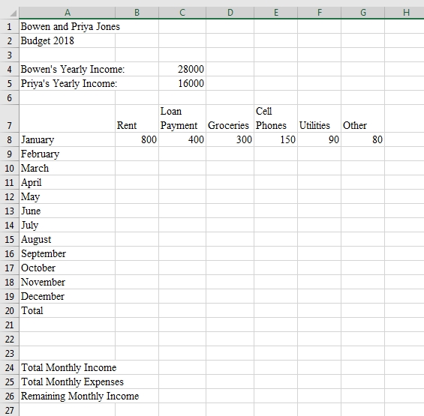

- Fill in the remaining months with the same amounts shown for January.

- Insert a column at the appropriate location (descending order of payment amounts) to add the Health Club payment of $75 paid quarterly (calculate and budget as a monthly expenditure—this requires a formula) and fill in for the remaining months.

- Insert another column, again in the appropriate location (descending order of payment amounts) to add the car insurance of $300 paid bi-annually (calculate and budget as a monthly expenditure—this requires a formula) and fill in for the remaining months.

- Lastly, insert a column at the far right of the table for Savings of $500 per month and fill in for the remaining months.

- In cell B20, create a formula to total the column. Fill to cells C20:J20.

- Delete the current Row 23.

- In cell C23, create a formula to find the total of the combined monthly income.

- In cell C24, create a formula to find the total for all monthly expenses plus savings.

- In cell C25, create a formula to calculate how much monthly money they have left after expenses and savings have been deducted from the monthly income.

- Adjust column widths, as needed so all information shows.

- Print a copy of the worksheet vertically and horizontally centered in landscape view to one page.

- Print a copy of the worksheet showing the formulas vertically and horizontally centered in landscape view to one page.

JOB 2: Format the Spreadsheet you created in Job 1 using the following instructions:

- Merge and center the title over the data. Bold and change to size 36 font.
- Merge and center subtitle. Change to size 20 font.
- Merge cells A4:B4, A5:B5, A23:B23, A24:B24 and A25:B25 but do not center them.
- Right align each column heading. Change font size to 14.
- Change column width to 14 for columns A-J.
- Apply black shading and bold white font to A7:J7.
- Change the number format for B8:J19 to Accounting with 0 decimal places and no $.
- Change the number format in row 20 to Accounting with 0 decimal places.
- Right align Total in A20.
- Apply black shading and bold white font to A20:J20.
- Change the number format of C23:C25 to Accounting with 2 decimal places.
- Format cells C4:C5 with the Currency style.
- Place a thick box border around the entire spreadsheet.
- Print out the formatted spreadsheet with it centered horizontally and vertically on one page.

JOB 3: Create a Donut Chart
Create a chart from the spreadsheet you have created in the previous jobs showing the monthly breakdown of the expenses and savings. It should be moved to its own sheet and formatted to look like the following. Title is size 36 font. Title the chart Breakdown of Monthly Expenses. Legend is size 18 font and should be located at the right. The legend can be as shown below (2 columns) or as a single column. Data labels are size 12 font. Print out on full sheet in grayscale.

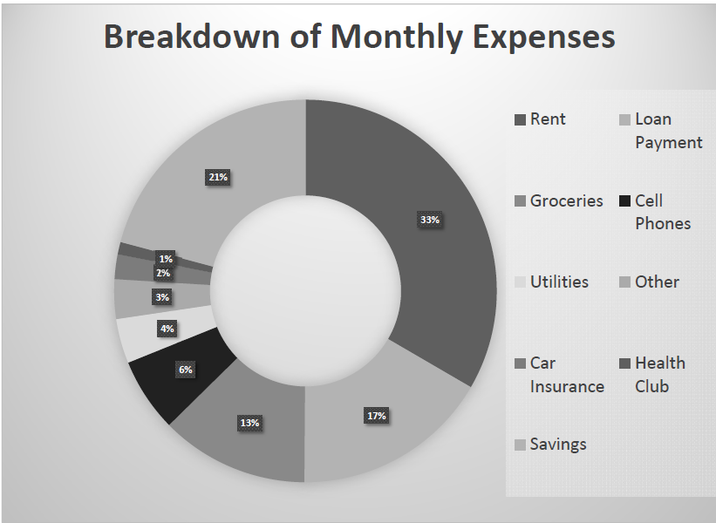

You should have the following four printouts:
Job 1—unformatted
Job 1—formulas
Job 2—formatted
Job 3—donut chart

