PROJECT MANAGEMENT
CONCEPTS
(593)

—OPEN EVENT—

—Post-secondary—

REGIONAL – 2016

DO NOT WRITE ON TEST BOOKLET

TOTAL POINTS ___________ (100)

Failure to adhere to any of the following rules will result in disqualification:
- Contestant must hand in this test booklet and all printouts. Failure to do so will result in disqualification.
- No equipment, supplies, or materials other than those specified for this event are allowed in the testing area. No previous BPA tests and/or sample tests or facsimile (handwritten, photocopied, or keyed) are allowed in the testing area.
- Electronic devices will be monitored according to ACT standards.

No more than 60 minutes testing time

Property of Business Professionals of America.
May be reproduced only for use in the Business Professionals of America
Workplace Skills Assessment Program competition.

Multiple Choice
Identify the choice that best completes the statement or answers the question.

- There is a total of _____ processes in project management.
  - 20
  - 27
  - 47
  - 60

- The five process groups of project management are Initiating, Planning, Executing, Monitoring/Controlling, and __________.
  - Risk-taking
  - Time
  - Cost
  - Closing

- _________ is one of the ten knowledge areas of project management.
  - Initiating
  - Sending
  - Scope
  - Phase

- Network schedules in a project are created by subtracting _________.
  - early finish – late finish
  - late finish – early finish
  - scope – duration
  - duration – scope

- Earned value management is a technique used to monitor progress of a project. All of these variables are used in Earned value management except
  - planned value.
  - actual cost.
  - earned value.
  - actual value.

- The cost performance index is calculated by
  - earned value/actual cost.
  - earned value–actual cost.
  - earned value/planned value.
  - earned value/actual value.

- A collection of programs, projects and additional work managed together to achieve goals is known as a ______________.
  - life cycle
  - constraint
  - operation
  - portfolio

- The collection of tools, methodologies, techniques, standards, and resources used to manage a project are known as the ____________.
  - project management office
  - project management information system
  - business value
  - project constraints

- A unique one-time endeavor with a defined beginning and end is a
  - program.
  - portfolio.
  - system.
  - project.

- The pursuit of a balanced portfolio of projects is known as ___________.
  - project management
  - program management
  - portfolio management
  - stakeholder analysis

- Which of these is not a responsibility or competency required to be an effective project manager?
  - Negotiation
  - Appearance
  - Motivation
  - Leadership

- In a functional organization, the employees have ___________ .
  - a matrix structure
  - one clear superior
  - multiple superiors
  - no clear superiors

- The second step in a project life cycle is the ____________ phase.
  - concept
  - implementation/execution
  - development/planning
  - termination/close

- A(n) _________ project life cycle is used when dealing with a rapidly changing environment such as software product development.
  - predictive
  - iterative
  - incremental
  - adaptive

- A tangible item in project management that is internal or external to the project, which is needed by a process to produce its output is a(n) _____________.
  - Tool
  - Technique
  - Input
  - Raw material

- Any formal or informal process, plans, policies, procedures, guidelines, and on-going or historical project information is known as _____________.
  - enterprise environmental factors
  - change management
  - organizational process assets
  - expert judgment

- The ___________ might be considered a first draft in understanding the project requirements.
  - project stakeholders
  - project managers
  - project charter
  - work breakdown structure

- __________ is a form of expert judgment that is used to accommodate unique project situations.
  - Compromising
  - Conformance
  - Tailoring
  - Experience

- Lessons learned for a project may be recorded ________ of the project.
  - at the end
  - at closing
  - at anytime
  - after closing

- ___________ is an analytical technique used during the monitor and control project work process of project management.
  - Valuation
  - Quality assurance
  - Asset procurement
  - Trend analysis

- Transitioning the project’s product, service, or results to operations or the next phase is an example of the _______ process.
  - close project or phase
  - close procurements
  - close stakeholders
  - close work breakdown structure

- The project manager reviews work results from the project scope activities. They will compare these against the __________.
  - project management plan
  - business case
  - project charter
  - work breakdown structure

- A project may be stopped if
  - the project is taking too long.
  - the project manager is transferred to a new project.
  - the stakeholder wants changes.
  - business case is eliminated or does not exist.

- The work that must be done to deliver the products or services of a project is called the _________.
  - product scope
  - project scope
  - project charter
  - project manager

- The 100% rule refers to developing the ______________.
  - code of accounts
  - planning package
  - scope baseline
  - work breakdown structure

- Deliverables of a project must be broken down into smaller, more manageable components. This process is called:
  - rolling wave planning.
  - chart of accounts.
  - decomposition.
  - controlling accounts.

- The project scope statement is the basis for future project decisions and is critical to the success of a project. Project objectives should follow the SMART guideline. SMART objectives are
  - Specific, Measurable, Assignable, Realistic, and Timely.
  - Short, Measureable, Assignable, Ready, and Timely.
  - Specific, Measurable, Assignable, Ready, and Timely.
  - Short, Maintainable, Assignable, Ready, and Timely.

- Which of these is a benefit of using the work breakdown structure in projects?
  - Reduces channels of communication
  - Gives a big picture view of the project
  - Brings focus to project objectives
  - Limits the handling of change control requests

- The validate scope process is the process of getting formal acceptance from __________ on completed project deliverables.
  - sponsors
  - supervisors
  - stakeholders
  - customers

- Many projects go through changes. A change management process usually includes an entity called a _____________ whose job is to review and approve/deny change requests.
  - stakeholder team
  - project manager
  - portfolio manager
  - change control board

- To improve planning and managing work on a project,
  - do not use the work breakdown structure.
  - use the lower levels of the work breakdown structure.
  - add stakeholders to the project.
  - allow anyone to attend planning meetings.

- An effective scope change control system will include
  - a rigid scope with very few changes allowed.
  - procedures to change the product scope.
  - procedures to change the project and product scope.
  - procedures to write a complete and unchangeable project scope.

- Time management is the part of project management that is concerned with the ____________.
  - project charter
  - project scope
  - stakeholders work hours
  - project schedule

- The critical path method is used to find the project path with the least float. Float is defined as __________.
  - amount of time that a schedule activity can be delayed without delaying the end of the project
  - amount of time that a schedule activity can be delayed
  - amount of delay in the end of a project
  - amount of time that a project can be delayed without interrupting a schedule activity

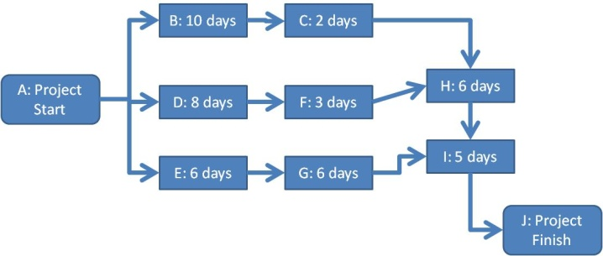

- In the above precedence diagram, what is the Critical Path?
  - ADFHIJ
  - ABCHIJ
  - AEGIJ
  - ADFHIJ

- Triangular or 3-point estimating takes the average of three estimated durations. They are
  - the optimistic value, most likely value and pessimistic value.
  - the first value, middle value and last value.
  - the mean value, median value and the standard deviation value.
  - the best value, worst value and a random value.

- Lag is used when there is ________.
  - predecessor activities happening concurrently
  - some acceleration needed on a project
  - a waiting period between a predecessor and a successor activity
  - a waiting period between a successor and a predecessor activity

- All of these are project estimating tools and techniques except
  - expert judgment.
  - analogous estimating.
  - parametric estimating.
  - crash estimating.

- You are the project manager on a development project that is 50% completed. If the cost performance index is 1.0, the total earned value to date is $5,000,000, and the original budget was $10,000,000, what is the actual cost?
  - $10,000,000
  - $5,000,000
  - $15,000,000
  - $3,333,333

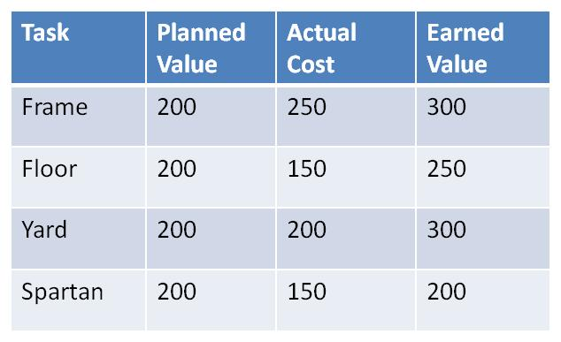
- In the above project, which task has been completed?
  - Frame
  - Floor
  - Yard
  - Spartan

- One example of cost of conformance to quality would be
  - training.
  - rejected materials.
  - reworking scrap.
  - warranty work.

- In project management, a responsibility assignment matrix is __________.
  - a structure that relates the stakeholders to location
  - a structure that relates project roles and responsibilities to the project scope
  - development of the virtual teams
  - how enterprise environmental factors are developed

- When decisions are made solely by the project manager with little or no input from the project team, this is an example of the ____________ leadership style.
  - consultative autocratic and persuading
  - autocratic and directing
  - consensus and directing
  - shareholder and persuading

- If you have five (5) people working on a project, how many channels of communication are there?
  - 5
  - 10
  - 15
  - 20

- When identifying project risks, the Delphi technique is a form of expert judgment in where ________.
  - change is collectively managed by the group
  - opinions are obtained from a panel of anonymous and independent experts
  - risks are collected by brainstorming
  - interviews are used to determine risks

- In a cost reimbursable contract, buyer and seller agree to the reimbursed costs and the __________.
  - amount of risk
  - duration of the project schedule
  - number of stakeholders
  - amount of profit

- The procurement agreement is an output of the conduct procurements process and may also be called the __________.
  - Purchase order
  - Arbitration
  - Withdrawal
  - Win-Win

- Stakeholder management is necessary in project management. One of the powers of a project manager is referent or ________ power.
  - reward
  - charisma
  - penalty
  - legitimate

- A project has an 80% chance of finishing on time and an 80% chance of finishing over budget. What is the probability the project will finish on time and over budget?
  - 6.4%
  - 0.64%
  - 64%
  - 80%

- In the initiating process group, there are two processes that are to be completed. They are
  - develop project management plan and identify stakeholders.
  - develop project charter and identify stakeholders.
  - develop stakeholders and initiate project.
  - develop project charter and initiate project.

