Contestant Number:
Time:
Rank:
VISUAL BASIC/C# PROGRAMMING
(330)

REGIONAL – 2016

Program: Character Stats (400 points)

TOTAL POINTS (400 points)

Failure to adhere to any of the following rules will result in disqualification:
- Contestant must hand in this test booklet and all printouts. Failure to do so will result in disqualification.
- No equipment, supplies, or materials other than those specified for this event are allowed in the testing area. No previous BPA tests and/or sample tests or facsimile (handwritten, photocopied, or keyed) are allowed in the testing area.
- Electronic devices will be monitored according to ACT standards.

No more than ten (10) minutes orientation
No more than 90 minutes testing time
No more than ten (10) minutes wrap-up

Property of Business Professionals of America.
May be reproduced only for use in the Business Professionals of America
Workplace Skills Assessment Program competition.

General Instructions

You work for XYZ Games, Inc., a company that develops multiple video games. You have been asked to develop a GUI application that will calculate character statistics.

Your deliverable for this project must include the following.

- Create a multi-form GUI application.
- The startup form, Main Form, must resemble Figure 1.
- The second form, the Hero Form, must resemble Figure 2.
- The application must adhere to proper naming conventions and include the required methods and functionality as mentioned in the specifications.

NOTES TO CONTESTANT
You will have 90 minutes to complete your work.

Your name and/or school name should not appear on any work you submit for grading.

Copy your entire solution/project to the flash drive provided. You must submit your entire solution/project so that the graders may open your project to review the source code. You must ensure that the files required to run your program are present and will execute on the flash drive provided.

Note that the flash drive letter may not be the same when the program is graded as it was when you created the program. It is recommended that you use relative paths rather than absolute paths to ensure that the program will run regardless of the flash drive letter. The graders will not compile or alter your source code to correct for this. Submissions that do not contain source code will not be graded.

The flash drive that you are provided must have three (3) pictures files for you. The files are:
- archer.png
- warrior.png
- wizard.png

Your application will be graded on the following criteria:

Solution and Project

The project is present on the flash drive ____ 5 points
The project is named according to the naming conventions ____ 5 points
Three (3) Character images are added to the project as Resources ____ 5 points

User Interface Design

Main Form
The Main Form resembles Figure 1 ____ 25 points
The name of the form is, “frmMain” ____ 5 points
The form’s caption displays “Contestant #01-2345-6789”, where
#01-2345-6789 is the contestant’s properly formatted BPA ID ____ 5 points
The user interface contains a label explaining Heroes ____ 5 points
The user interface contains a button named, “btnHero” ____ 5 points
The user interface contains a button captioned, “Hero” ____ 5 points
The user interface contains a label explaining Villains ____ 5 points
The user interface contains a button named, “btnVillain” ____ 5 points
The user interface contains a button captioned, “Villain” ____ 5 points
The user interface contains a button named, “btnExit” ____ 5 points
The user interface contains a button captioned, “E&xit” ____ 5 points

Hero Form
The Hero Form resembles Figure 2 ____ 25 points
The name of the form is, “frmHero” ____ 5 points
The form’s caption displays “Hero Stats” ____ 5 points
Listbox for hero characters name “lstHero” ____ 5 points
Listbox for hero characters is not pre-populated ____ 5 points
PictureBox is implemented and image is not pre-populated ____ 5 points
Groupbox for skill level is populated with correct skill levels ____ 15 points
Groupbox for character stats is populated with the correct attributes ____ 15 points
A button named, “btnCalculate”, is defined ____ 5 points
A button captioned, “&Calculate”, is defined ____ 5 points
A button name, “btnBack”, is defined ____ 5 points
A button captioned, “&Back to Side Selector”, is defined ____ 5 points

Runtime Checks
Code copied to USB drive and program runs from the USB drive ____ 5 points

If the program does not execute, then the remaining items in this section receive a score of zero

When the Hero button is clicked, the Hero Form is displayed ____ 25 points
When the Villain button is clicked, a coming soon message is displayed ____ 10 points
When the user attempts to close the application, a confirmation dialog
is presented that confirms that the user wishes to exit the application ____ 15 points
User is prompted if they did not select a hero from Hero Listbox ____ 10 points
Application correctly calculates character’s individual stats and total XP ____ 25 points

Source Code Review

Code is commented at the top, for each function, and as needed ____ 15 points
Code uses consistent variable naming conventions ____ 10 points

Main Form
An instance of the Hero Form is created and displayed on click of Hero button ____ 20 points

Hero Form
A method called, ResetValues(), is utilized to reset all controls ____ 20 points
A method called, CalcHeroLevels(), is utilized to calculate the appropriate
character stats based on the Skill Level selected ____ 20 points
CalcHeroLevels() method displays the strength, speed, armor, magic,
and total XP to the appropriate labels ____ 15 points
PictureBox image is assigned via code when Hero Listbox item is selected ____ 20 points

Total: ____ 400 points

Technical Specifications
- Solution and Project
  - Create a Windows Form Application named 330_ContestantNumber, where ContestantNumber is your BPA assigned contestant number. When naming your project, replace dashes (-) with the underscore (_). For example, if your BPA contestant number is 01-2345-6789, then your project name would be 330_01_2345_6789.
- User Interface
  - The user interface to be constructed is shown in Figure 1 and Figure 2. Your application must resemble the prototype (see Figure 1 and Figure 2).
  - The Main Form
    - The name of the main form should be “frmMain.”
    - The Form’s caption must be set to “Contestant #01-2345-6789”, where 01-2345-6789 is your BPA assigned contestant number (including dashes).
    - User interface elements and default (design-time) property settings
      - Exit Button
        - The name of this button must be cmdExit
        - The text property for this button must be set to “E&xit”
      - Hero Button
        - The name of this button must be “btnHero”
        - The text property for this button must be set to “&Hero”
      - Villain Button
        - The name of this button must be “btnVillain”
        - The text property for this button must be set to “&Villain”
      - Group Box
        - A group box called, “grpSelectSide” must be created
        - The group box must have the caption ‘Select a Side’
  - The Hero Form
    - The name of the main form should be “frmHero.”
    - The Form’s caption must be set to “Hero Stats”.
    - User interface elements and default (design-time) property settings
      - Hero Listbox
        - The name of this listbox must be “lstHero”
        - The list box should be populated with three choices:
          - Archer
          - Warrior
          - Wizard
      - PictureBox
        - The name of this picture box must be “picHero”
        - Sizemode should be set to StretchImage
        - The PictureBox image will set via code when a character is selected from the Hero listbox.

      - Skill Level Group Box
        - Group box is populated with radio buttons with the following names and text properties
          - Level 1, radLevel1
          - Level 10, radLevel10
          - Level 25, radLevel25
          - Level 50, radLevel50
          - Level 75, radLevel75
          - Level 99, radLevel99
        - The group box must have the caption “Select a skill level”
      - Character Stats Group Box
        - Group box is populated with labels for the following:
          - Strength
          - Speed
          - Armor
          - Magic
          - Total XP
        - The group box must have the caption “Character Stats”
      - Back to Side Selector Button
        - The name of this button must be “btnBack”
        - The text property for this button must be set to “&Back to Side Selector”
      - Calculate Button
        - The name of this button must be “btnCalculate”
        - The text property for this button must be set to “&Calculate”
- Tasks
  - Main Form - Exit Button Click
    - Closes the form. Upon closing, the application must confirm that the form is to be closed and allow the user to cancel the close by responding with “No” to the question, “Do you wish to exit this application?” If the user responds with a “Yes”, then the application is closed.
    - The message box used to solicit the response must contain the message, “Do you wish to exit this application?” with a caption of “Exit?”
    - The dialog box used to solicit the response must contain two buttons: Yes and No.
  - Main Form - Hero Button Click
    - Open the Hero Form (frmHero)
  - Main Form - Villain Button Click
    - Display a message to the user with the following message: “Coming soon: Select a villain” (see Figure 3).

  - Hero Form – Calculate Button Click
    - This procedure must validate whether or not a hero has been selected. If the user did not select a hero yet, a message should prompt the user.
    - Upon click, a method named “CalcHeroLevels” is called.
      - This method will calculate all of the character stats for the selected hero and skill level (see Figure 4 for a table of hero base stats)
      - If a character is not selected from the Hero Listbox, the user should be prompted to select a character. Stats should not display if a character has not been selected.
      - The total XP (Experience Points) is calculated by added the strength, speed, armor, and magic attributes.
      - The stats for each attribute are based on a multiplier in the following list (for example, a Level 10 Warrior would have each attribute multiplied by 2):
        - Level 1 – 1x multiplier
        - Level 10 – 2x multiplier
        - Level 25 – 3x multiplier
        - Level 50 – 4x multiplier
        - Level 75 – 5x multiplier
        - Level 99 – 6x multiplier
- Hero Form – Back to Side Selector Button
    - Closes the Hero form
- Hero Listbox Selection
    - Upon selecting a hero from lstHero, a method called “ResetValues()” must be called.
      - ResetValues() should reset the skill Level to Level 1 and all character stats should be reset to empty strings.
    - Upon selecting a hero from lstHero, the correct image should populate in the picHero picture box
      - Reminder: the images are on the USB provided to you. If images were not provided, please contact the contest Administrator.
      - The images must be added to the project as a resource.
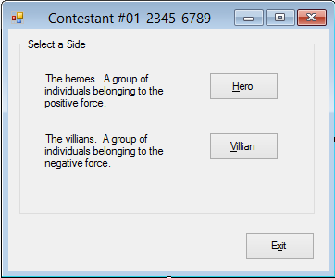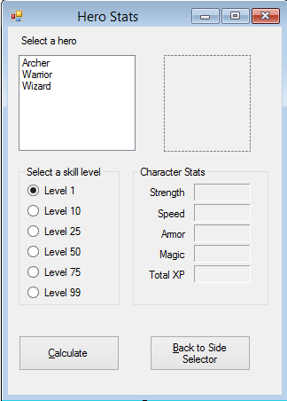
Figure 1 Figure 2
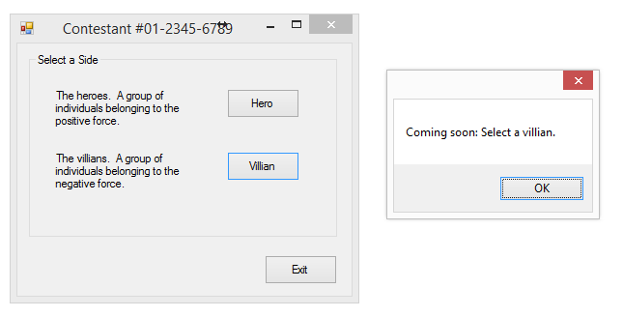
Figure 3

Attribute (Level 1 Stats) | Archer | Warrior | Wizard
Strength | 100 | 150 | 200
Speed | 145 | 115 | 400
Armor | 80 | 120 | 100
Magic | 100 | 90 | 600
Figure 4 – Hero base stats

Development Standards
- Standard name prefixes must be utilized for forms, controls, and variables.
- All subroutines, functions, and methods must be documented with comments explaining the purpose of the method, the input parameters (if any), and the output (if any).
- The user interface must be similar to Figure 1 and 2.

Example Scenarios

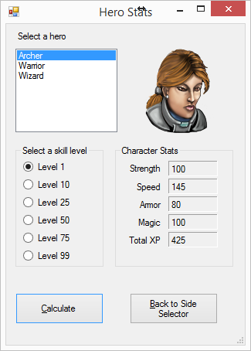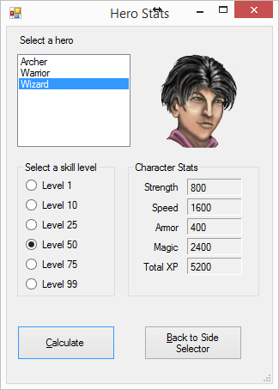
Archer on Level 1 Warrior on Level 50

