Contestant Number:
Time:
Rank:

SYSTEMS ADMINISTRATION USING CISCO®
(315)

REGIONAL – 2016

Multiple Choice:
Multiple Choice (50 @ 10 points each) (500 points)
TOTAL POINTS (500 points)

Failure to adhere to any of the following rules will result in disqualification:
- Contestant must hand in this test booklet and all printouts. Failure to do so will result in disqualification.
- No equipment, supplies, or materials other than those specified for this event are allowed in the testing area. No previous BPA tests and/or sample tests or facsimile (handwritten, photocopied, or keyed) are allowed in the testing area.
- Electronic devices will be monitored according to ACT standards.

No more than 60 minutes testing time

Property of Business Professionals of America.
May be reproduced only for use in the Business Professionals of America
Workplace Skills Assessment Program competition.
Identify the letter of the choice that best completes the statement or answers the question. Mark A if the statement is true. Mark B if the statement is false.

- Cisco refers to the creation of online communities as:
  - Global communities
  - The Internet
  - The Human Network
  - Online Communities

- You want to see if any VLANs have been created on the switch. Which command do you enter at the prompt?
  - Show flash/
  - Show dir flash:
  - Dir flash/
  - Dir flash:

- The OSI Model consists of seven layers. These layers are:
  - Application, Transport, Physical, Data Link, Presentation, Session, and Network
  - Transfer, Application, Physical, Network, Data Link, Session, and Presentation
  - Internet, Data Link, Transport, Session, Application, Presentation, and Network Access
  - Session, Data, Network, Transport, Presentation, Network, and Application

- At the console prompt,-- Switch(config) #, the Administrator decides to change the name of the switch. The following command is entered: hostname SalesDepartment. What will be the displayed prompt after issuing the command?
  - SalesDepartment(config)#
  - Sales(config)#
  - Switch(config)#
  - Switch#

- Based on the given MAC address: 30:ae:12:34:bd:56, which numbers/letters indicate the NIC serial number?
  - 34:bd:56
  - 12:34:bd
  - 30:ae:12:34:bd:56
  - 30:ae:12

- A MAC address is a ________ bit address.
  - 32
  - 48
  - 64
  - 128
- What factor listed usually does not influence throughput?
  - Amount of traffic
  - Type of traffic
  - Type of media used
  - Latency created by the number of devices

- You would use a _________ cable to connect a PC to a FastEthernet port on a Router.
  - Rollover
  - Straight through
  - Cross over
  - Fiber Optic

- What wireless standard supports a maximum bandwidth of 54 Mb/s and a frequency of 2.4 GHz?
  - 802.11a
  - 802.11b
  - 802.11n
  - 802.11g

- Which OSI layer prepares the network layer packets for transmission and controls access to the physical media?
  - Session
  - Physical
  - Data-Link
  - Transport

- The two network topologies used for connections and placement of devices and interconnections are:
  - Physical and Virtual
  - Star and Bus
  - Logical and Physical
  - Token Ring and Star

- The WAN topology with the highest availability is:
  - Point-to-Point
  - Bus
  - Hub and Spoke
  - Mesh

- Most common LAN topology is:
  - Bus
  - Star
  - Ring
  - Extended Star

- What is the method used to manage contention-based media in a wired network?
  - CSMA/DC
  - CMSA/DC
  - CSMA/CD
  - CMSA/CS

- The Administrator wants to add an IP address to a FastEthernet port on the router. At the prompt, Router(config)# the following command is entered: ip address 192.168.1.1 255.255.255.0. What will be displayed after completing that command?
  - Router(config)#
  - Router(config)# incomplete command
  - Router(config-if)#
  - % Invalid input detected at `^` marker

- What is one way ARP can collect MAC addresses?
  - Monitor traffic that occurs on the local network and record the source IP and MAC address for the ARP table
  - Send out a multicast address across the network and resolve the MAC address from the response
  - A network broadcast message is sent across the LAN requesting MAC addresses
  - Ping the default gateway and view the response using the arp-a command

- Which protocol is considered a connectionless protocol?
  - UDP
  - TCP
  - IP
  - IPX

- A default gateway is not required for:
  - Local default route
  - Connections to forward packets to remote networks
  - Connections to forward packets to local networks
  - Local Network route

- The Administrator enters, enable secret, at the Router(config)# prompt; what affect does this have on the router?
  - Protects access to the Privileged EXEC mode
  - Changes the Global Configuration mode password
  - Changes the Privileged Exec mode password
  - Protects access to global configuration mode

- The layer responsible for establishing communications and transmitting data is ___________.
  - Network
  - Data-Link
  - Transport
  - Session

- Streaming video uses which protocol?
  - IP
  - UDP
  - TCP
  - VoIP

- An IPv4 address contains how many bits?
  - 16
  - 32
  - 64
  - 128

- The private IP address range in a Class B network address starts with:
  - 172.16.1.0
  - 172.16.0.0
  - 172.160.1.0
  - 172.160.0.0

- A 48-port switch with only the default VLAN configured has a computer connected to each port and all ports are on. What is the number of broadcast domains?
  - 48
  - None
  - One
  - 24

- Define the term broadcast domain.
  - A set of devices that if one device sends a broadcast frame all other devices will receive that frame in the same broadcast domain.
  - A set of devices that will send out frames from all ports except the ingress port.
  - All devices, equipment, and hosts on a LAN segment.
  - A domain used to send information to all users on that network segment.

- If you borrow 3 bits from the host portion of the network address when subnetting a network, how many subnets will you create?
  - 3
  - 4
  - 6
  - 8

- Given the network address 172.16.0.0/18, what is the subnet mask address?
  - 255.255.128.0
  - 255.255.192.0
  - 255.255.240.0
  - 255.255.255.0

- A simple method that Administrators use to help secure the switch from unauthorized access is to _______.
  - unplug cables from unused ports.
  - set up a traffic monitoring system on the switch.
  - disable all unused ports.
  - keep the switch locked in the MDF.

- VLANs are implemented for which of the following reasons:
  - Segmentation of the network for security purposes
  - To improve network performance
  - Implement access and security policies according to specific groups
  - All of the above

- Which of the listed port numbers are for FTP?
  - 18, 19
  - 20, 21
  - 22, 23
  - 24, 25

- When designing an ACL, which is not the rule of Three P’s?
  - Onc ACL per protocol
  - Onc ACL per direction
  - One ACL per device
  - One ACL per interface

- If the Network Administrator is writing an ACL and enters the following at the prompt what application is being allowed through this ACL?
  - HTTP
  - FTP
  - Telnet
  - SSH

- What is a trunk connection?
  - Data and voice sent on the same interface
  - The link of a VLAN that is referred to as the native VLAN for that specific port
  - Link that provided access for multiple VLANs
  - VLAN connection to the default gateway

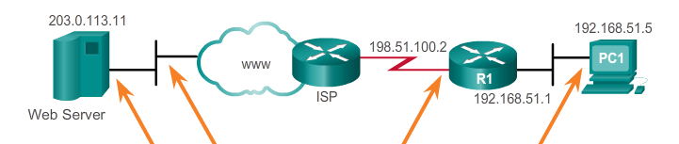
D
C
B
A

- Refer to the above diagram to answer questions 34 and 35.
Segment “A” refers to which NAT address:
- Inside Local
- Outside Global
- Inside Global
- Outside Local

- Segment “C” refers to which NAT address?
- Inside Local
- Outside Global
- Inside Global
- Outside Local

- STP (Spanning Tree Protocol) was developed to address which of the following issues?
  - Loops and duplicate frames
  - Loops and broadcast storms
  - Duplicate frames and link redundancy
  - Loops and port aggregation

- STP uses the Spanning Tree Algorithm (STA) which defines the port roles based on path cost. Which of the roles listed below are not roles defined by the STA?
  - Root Port
  - Alternate Port
  - Edge Port
  - Designated Port

- Which of the devices listed below will the Network Administrator most commonly use to connect multiple devices on the same LAN?
  - Router
  - Switch
  - Hub
  - Bridge

- What is the most cost-effective method of relieving port congestion caused by increased traffic between switches?
  - Add a router between switches
  - Port aggregation
  - Increase the number of VLANs
  - Increase the switch-to-switch uplink connection speed

- The Bluetooth IEEE 802.15 standard long distance range is _____________.
  - 10 meters
  - 20 meters
  - 50 meters
  - 100 meters

- When wireless clients interconnect via a wireless router or AP, it is considered to be a(n) ___________.
  - Ad Hoc mode
  - Basic Service Area (BSA)
  - Infrastructure mode
  - Extended Service Set (ESS)

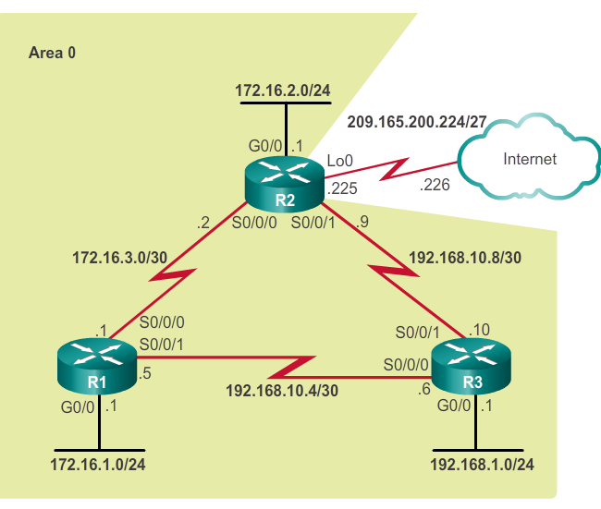
- Refer to the diagram above. If the Network Administrator has decided to create a default route to the service provider, what is the command to create the default route?
  - ip route 0.0.0.0 0.0.0.0 209.165.200.225
  - ip route 0.0.0.0 0.0.0.0 209.165.200.226
  - ip route 209.165.200.225 0.0.0.0 0.0.0.0
  - ip route 209.165.200.226 0.0.0.0 0.0.0.0

- A Network Administrator is tasked with designing an expanded network for the company. After discussion with various branches of the company, it is decided to use the Cisco three-layer hierarchical model design. Which of the layers is not part of this model?
  - Core
  - Access
  - Intermediate
  - Distribution

- WAN operations focus mainly of which two layers?
  - One and two
  - Three and four
  - Five and six
  - Six and seven

- On a WAN connection, which connection requires a clock rate?
  - DTE
  - CPE
  - DCE
  - CO

- A disadvantage of leased lines in a WAN architecture is __________________.
  - simplicity
  - quality
  - cost
  - availability

- A WAN technology that provides the user with cost savings, security, scalability, and compatibility with broadband technologies is ___________________.
  - ISDN
  - DSL
  - Frame-Relay
  - VPN

- Which WAN technology utilizes a permanent dedicated point-to-point connection?
  - Frame-Relay
  - ATM
  - VPN
  - Leased lines

- Time-Division Multiplexing, (TDM) operates at which layer of the OSI model?
  - Layer 1
  - Layer 3
  - Layer 5
  - Layer 2

- Which tunneling protocol, developed by Cisco, can encapsulate a wide variety of packets inside IP tunnels, creating virtual point-to-point links to Cisco routers at remotes points over an IP internetwork?
  - L2TP
  - SSH
  - VPN
  - GRE

