Contestant Number:
Time:
Rank:

PC SERVICING &
TROUBLESHOOTING
(305)

REGIONAL – 2016

TOTAL POINTS ___________ (500)

Failure to adhere to any of the following rules will result in disqualification:
- Contestant must hand in this test booklet and all printouts. Failure to do so will result in disqualification.
- No equipment, supplies, or materials other than those specified for this event are allowed in the testing area. No previous BPA tests and/or sample tests or facsimile (handwritten, photocopied, or keyed) are allowed in the testing area.
- Electronic devices will be monitored according to ACT standards.

No more than 60 minutes testing time

Property of Business Professionals of America.
May be reproduced only for use in the Business Professionals of America
Workplace Skills Assessment Program competition.

Identify the letter of the choice that best completes the statement or answers the question. Mark A if the statement is true. Mark B if the statement is false.

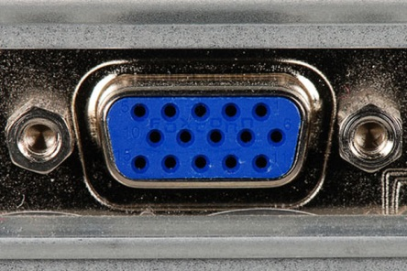
- Identify the port in the above figure.
- HDMI port
- Firewire port
- VGA port
- Parallel port

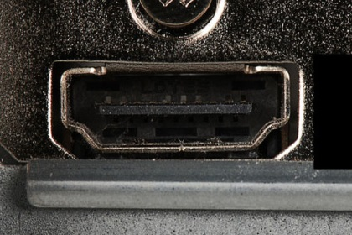
- Identify the port in the above figure.
- HDMI port
- DVI port
- Serial port
- Ethernet port

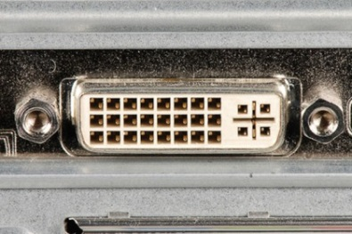
- Identify the port in the above figure.
- Serial port
- VGA port
- DVI port
- HDMI port

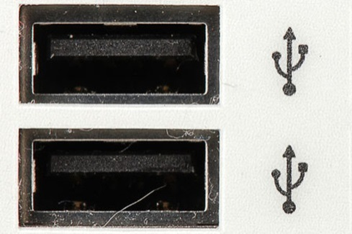
- Identify the ports in the above figure.
- VGA ports
- USB ports
- HDMI ports
- Firewire ports

- How many devices can be connected to a wide SCSI?
  - 7
  - 8
  - 10
  - 15

- What term is used to describe a device that can be connected and the drivers installed without restarting the computer?
  - Hot-swappable
  - Cold-swappable
  - Legacy
  - Native

- A single USB port in a computer can support up to separate devices with the use of multiple USB hubs.
  - 63
  - 127
  - 15
  - 7

- What is another name for FireWire?
  - i.Link
  - 1284 cable
  - Thunderbolt
  - Alt-4

- What is the temporary storage for data and programs that are being accessed by the CPU?
  - ROM
  - SRAM
  - RAM
  - PROM

- What type of method is used by RAID to write data across multiple drives?
  - Mirroring
  - Parity
  - Striping
  - Segmentation

- What is the maximum length of a parallel cable before data integrity is compromised?
  - 15 feet
  - 50 feet
  - 100 feet
  - 100 meters

- What is a fact sheet that summarizes information about material identification, including hazardous ingredients that can affect personal health, fire hazards, and first-aid requirements?
  - MSDS
  - OSHA
  - IEEE
  - CDC

- What is used to test the integrity of circuits and the quality of electricity in computer components?
  - Loopback adapter
  - Tone and probe set
  - Digital multimeter
  - Cable tester

- What tool checks the integrity of files and folders on a hard drive by scanning the file storage system and may also check disk surfaces for physical errors?
  - Fdisk
  - MMC
  - Format
  - Scandisk

- What type of power connection is used with a CD-ROM and a traditional hard drive?
  - Berg
  - 20-pin
  - 4-ping
  - Molex

- What type of power connection is used with a floppy drive?
  - Molex
  - Berg
  - 4-pin
  - 20-pin

- When booting a computer, what performs a check on all of the internal components?
  - BIOS
  - NTLoader
  - Kernel
  - Device manager

- What is meant when the computer is capable of operating multiple applications at the same time?
  - Multi-user
  - Multi-processing
  - Multi-tasking
  - Multi-threading

- What contains information about application, users, hardware, network settings, and file types?
  - Device Manager
  - Kernel
  - MMC
  - Registry

- Which of the following Operating Systems is considered to be a totally open source?
  - Windows Vista
  - Linux
  - Mac OS
  - Unix

- What is a detailed inventory of hardware that has been tested and is known to work with the operating system?
  - HCL
  - ACL
  - MMC
  - Device Manager

- How many partitions can you have on a hard drive?
  - 2
  - 4
  - 8
  - 16

- How many extended partitions can you have on a hard drive?
  - 1
  - 2
  - 4
  - 8

- What is the smallest unit of space used for storing data?
  - Sector
  - Cluster
  - Track
  - Cylinder

- What is the name for one complete circle of data on one side of a hard drive platter?
  - Sector
  - Cylinder
  - Track
  - Cluster

- Bluetooth is an example of what type of network?
  - MAN
  - WAN
  - LAN
  - PAN

- A walkie-talkie is an example of:
- Half duplex transmission
- Full duplex transmission
- Simplex transmission
- All of the above

- A cell phone is an example of:
- Half-duplex transmission
- Full-duplex transmission
- Simplex transmission
- None of the above

- How many bits are in an IPv6 address?
- 32
- 64
- 128
- 256

- What type of IPv4 addresses cannot be routed over the Internet?
- Public
- Class A
- Class D
- Private

- Which operating system uses the HFS+ file system?
- Windows 8
- Windows Vista
- Apple IOS
- Unix

- Which files system attribute is set when a file is ready to be backed up?
- S
- A
- R
- H

- What is used to interface the user with the kernel?
- Application
- Process
- Command Interpreter
- Shell
- What is the name given to an instance of a computer program being executed?
- Process
- Procedure
- Task
- Application

- Convert hexadecimal 81 to decimal.
- 129
- 8A
- 131
- 8B

- Convert 107 to hexadecimal.
- 67
- 6B
- 6A
- A7

- Convert 3MB to Kb.
- 3000 Kb
- 3072 Kb
- 24576 Kb
- None of the above

- For a program to be executed, it must be in the ________.
- Main Memory
- Secondary Memory
- Process Manager
- Protection Manager

- A customer lives in a remote area deep in a valley and cannot afford broadband. What is the best solution?
- Dial-up
- Cable
- Satellite
- DSL

- Your employer wants all remote connections to use only secure tunnels for data communications. Which encryption method is used to secure data as it travels across the public Internet as if it were traveling across a private LAN?
  - MD5
  - VPN
  - WEP
  - WPA

- What types of addresses are used to identify I/O ports?
  - Binary
  - IP
  - Hexadecimal
  - MAC

- How many pin connectors are found in a narrow SCSI cable?
- 25
- 50
- 68
- 80

- Which of the following is controlled by the Northbridge?
- I/O ports
- USB ports
- Video Card
- Hard drive

- Which of the following is not controlled by the Southbridge?
- RAM
- Sound card
- USB ports
- Hard drive

- Solid state drives (SSD) contain no moving parts.
- True
- False

- Which of the following is not a function of an operating system?
- Control hardware access
- Manage files and folders
- Provide cache for the processor
- Manage applications

- Which registry contains information relating to all active devices on a system?
- HKEY_Classes_Root
- HKEY_Current_User
- HKEY_Users
- HKEY_Current_Config

- What does a DLL file consists of?
- Program code that can be used by different programs to perform common functions
- Program code that can be used by a specific program to perform specialized functions
- File format used only by a Linux operating system
- File extension used by legacy drivers

- What file does Windows 7 use to configure a dual boot system?
- BootINI
- BootMGR
- BootLoader
- Master boot record

- Windows naming convention allows how many letters to be used in a file name?
- 128
- 255
- 256
- 512

