DATABASE APPLICATIONS
(240)

REGIONAL – 2016

Production:

Job 1: Employee Table (200 points)

Job 2: Management Table ( 90 points)

Job 3: Create a Permanent Relationship ( 25 points)

Job 4: Performance Review Query ( 50 points)

Job 5: Performance Review Report ( 35 points)

TOTAL POINTS (400 points)

Judge/Graders: Please double check and verify all
scores and answer keys!

Property of Business Professionals of America.
May be reproduced only for use in the Business Professionals of America
Workplace Skills Assessment Program competition.

Unless indicated otherwise, contestant receives all points or none. | Points Possible | Points Earned
Job 1 – Employee Table (200 points maximum)
Designed as instructed (10 points off per field for inaccurate field names, inappropriate data types, and properties not set as instructed) | 80
Proofreading/data entry  (100 – 0 errors; 90 – 1 error; 70 – 2 errors; 0 – 3+ errors) | 100
Sorted by “Last Name” (ascending) | 10
Printed using best fit in landscape orientation (all data shows, 1 page) | 10
Job 2 – Management Table (90 points maximum)
Designed as instructed (10 points off per field for inaccurate field names, inappropriate data types, and properties not set as instructed) | 20
Proofreading/data entry (1 point off for each error)  (50 – 0 errors; 45 – 1 error; 35 – 2 errors; 0 – 3+ errors) | 50
Sorted by ‘Department’ in ascending order | 10
Printed in portrait orientation, 1 page, all fields fully visible | 10
Job 3 – Create a Permanent Relationship (25 points maximum)
One-to-Many relationship created | 10
Referential integrity enforced | 10
Printed with both tables fully visible | 5
Job 4 – Performance Review Query (50 points maximum)
Correct fields are visible: Emp Id, First Name, Last Name, Department, Manager (5 points off for each missing field) | 25
Sorted by “Department” (ascending) and then by Employee Last Name (ascending) | 10
Results show design correctly joins both tables (no extra records) | 10
Printed in landscape orientation, 1 page, all fields fully visible | 5
Job 5 – Performance Review Report (35 points maximum)
Title is PerformanceReview-XX-XXXX-XXXX | 5
Correct fields are included in the Report: all fields in the query except Emp ID | 10
Sorted by Employee’s “Last Name” | 10
Printed in portrait orientation, 1 page, all fields fully visible | 10
Total Points Earned | 400

Job 1: Employee Table

Print: Sorted by Last Name, Ascending order; landscape, all data visible on one page
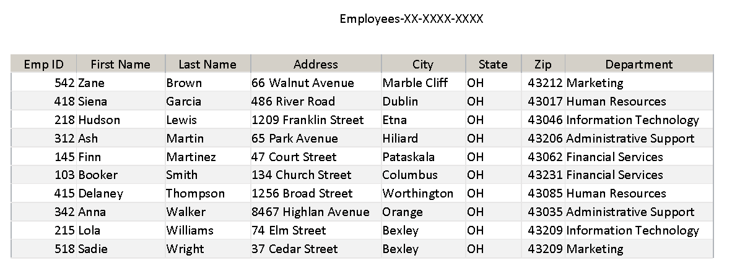

Job 2: Department Table
Printed: Sorted by Department (ascending order); portrait orientation, all data visible on one page:
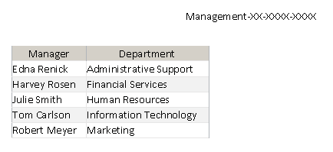

Notes: Manager and Department fields should match.

Job 3: Create a Permanent Relationship

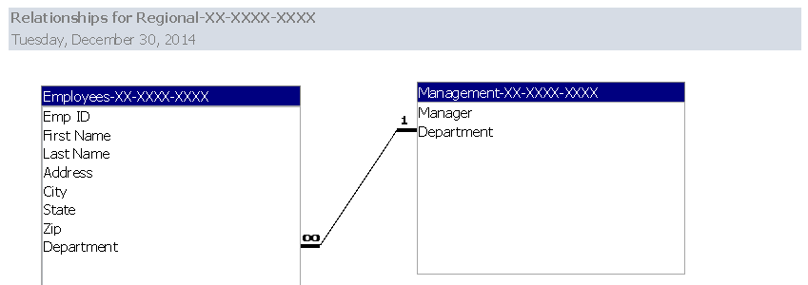
Note: All fields from both tables should be visible.

Job 4: Performance Review Query
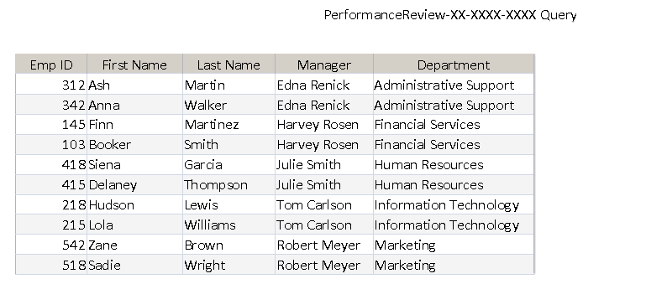
Printed in landscape orientation, all data visible.

Note: Must match this order of records (Department ascending then Last Name ascending)

Job 5: Performance Review Report

Note: Borders, colors, and placement of fields may be different. Must:
- Have the same title.
- Show the same fields.
- Sort by Last Name (ascending order)
- Have field widths/placement adjusted so all data is visible on one page in Portrait orientation.

