FUNDAMENTAL SPREADSHEET
APPLICATIONS
(230)

REGIONAL – 2016

TOTAL POINTS (650 points)

Judge/Graders: Please double check and verify all scores and answer keys!

Property of Business Professionals of America.
May be reproduced only for use in the Business Professionals of America
Workplace Skills Assessment Program competition.

RUBRIC
ON EACH ITEM CONTESTANTS EARN EITHER ALL THE POINTS OR NONE EXCEPT FOR TYPOS.
Printout 1 Worksheet—Job 1 | Possible Points | Total Points
ITEM NO entered as a label, not a value (aligned left) | 10
Heading AMT changed to AMOUNT | 10
Main heading is merged and centered across columns of information | 20
Amount for each item is correct | 20
1st subtotal is correct | 10
Tax amount is correct | 10
Shipping amount is correct | 10
2nd subtotal is correct | 10
Discount is correct | 10
TOTAL is correct and is in bold | 20
Column headings are centered | 10
Printed with gridlines, column and row headings, and centered on page | 30
Total Points, Printout 1 | 170
Printout 2—Job 1 with Formulas Showing | Possible Points | Total Points
AMOUNT column formula correct | 20
1ST subtotal formula correct | 20
Tax formula is correct | 20
Shipping formula is correct | 20
2nd subtotal formula correct | 20
Discount formula is correct | 20
Total formula is correct | 20
Printed showing formulas on one page | 20
Total Points, Printout 2 | 160

Printout 3 Worksheet—Job 2 | Possible Points | Total Points
Title is correct and is merged and centered above columns of information | 20
Subtitle is correct and is merged and centered above columns of information | 20
Data is entered correctly and formatted correctly | 20
Asset projections are done correctly (-5 points each error) | 30
Liability projections are done correctly (-5 points each error) | 30
Total Assets amounts correct and Total Liabilities amounts correct | 20
Net Worth amounts are correct | 20
Printed without gridlines showing and fit to one page | 10
Total Points, Printout 3 | 170
Printout 4 Formulas—Job 2 | Possible Points | Total Points
Total Assets formula correct | 10
Total Liabilities formula correct | 10
Net Worth formula correct | 10
Printed on one page | 10
Total Points, Printout 4 | 40
Printout 5—Job 2 Chart | Possible Points | Total Points
3-D clustered column chart created | 20
Chart shows projected Total Assets, Total Liabilities, and Net Worth for years 2015-2018 | 30
Chart is titled correctly | 20
Legend is placed on the right | 20
Chart created on new sheet | 20
Total Points, Printout 5 | 110
Total Points | 650

Printout 1
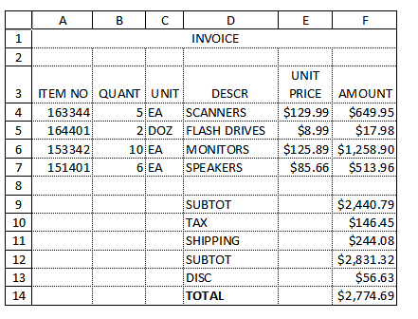
Printout 2
