Contestant Number:

Time:

Rank:

SYSTEMS ADMINISTRATION USING CISCO®

(315)

REGIONAL – 2015

**Multiple Choice:**

Multiple Choice (50 @ 10 points each) (500 points)

***TOTAL POINTS (500 points)***

**Failure to adhere to any of the following rules will result in disqualification:**

1. **Contestant must hand in this test booklet and all printouts. Failure to do so will result in disqualification.**
2. **No equipment, supplies, or materials other than those specified for this event are allowed in the testing area. No previous BPA tests and/or sample tests or facsimile (handwritten, photocopied, or keyed) are allowed in the testing area.**
3. **Electronic devices will be monitored according to ACT standards.**

No more than 60 minutes testing time

Property of Business Professionals of America.

May be reproduced only for use in the Business Professionals of America

*Workplace Skills Assessment Program* competition.

**Multiple Choice**

**Answer the multiple choice questions using the Scantron scoring form provided. Write your contestant name, along with the contest number on the Scantron form.**

**If you finish before the end of the 60 minutes of testing, notify the proctor. Time may be a factor in determining the winner in the event of a tie.**

____ 1. From the list below, the cabling that will send a signal the longest distance is ___.

|  |  |  |  |
| --- | --- | --- | --- |
| A. | Multimode Fiber | C. | STP cable |
| B. | Single Mode Fiber | D. | Coaxial cable |

____ 2. In which situations would a crossover UTP cable be used when connecting network devices (select ALL that apply).

|  |  |  |  |  |
| --- | --- | --- | --- | --- |
| A | switch to switch |  | E | PC NIC to switch |
| B | PC NIC to router FastEthernet |  | F | PC COM to router FastEthernet |
| C | PC NIC to router console |  | G | switch to router |
| D | PC NIC to PC NIC |  | H | PC COM to router console |

|  |  |  |  |
| --- | --- | --- | --- |
| A. | B, G, D | C. | A, G, H |
| B. | C, F, H | D. | A, B, D |

____ 3. Which of the following is ***not*** found in a routing table?

|  |  |  |  |
| --- | --- | --- | --- |
| A. | Metric | C. | Next-hop |
| B. | Destination network | D. | Destination MAC |

____ 4. The name of the PDU at the Transport Layer is a(n) ___ .

|  |  |  |  |
| --- | --- | --- | --- |
| A. | frame | C. | segment |
| B. | bit | D. | packet |

____ 5. The purpose of an ARP request is to ___

|  |  |  |  |
| --- | --- | --- | --- |
| A. | learn a layer 3 address when a layer 2 address is known. | C. | convert a domain name into a layer 2 address. |
| B. | convert a domain name into a layer 3 address. | D. | learn a layer 2 address when the layer 3 address is known. |

____ 6. Changing the format of data and adding a header is called ___.

|  |  |  |  |
| --- | --- | --- | --- |
| A. | encapsulation | C. | signaling |
| B. | encoding | D. | decapsulation |

____ 7. What can be determined when looking at the Data Link header?

|  |  |  |  |
| --- | --- | --- | --- |
| A. | The destination MAC address | C. | The source IP address |
| B. | The bits of data that cross the network | D. | The destination process or service |

____ 8. Using a reliable Layer 4 protocol, how is the rate of transmission slowed when there is a problem with network transmissions?

|  |  |  |  |
| --- | --- | --- | --- |
| A. | The segment size is reduced. | C. | The segment size is increased. |
| B. | The window size is reduced. | D. | The window size is increased. |

____ 9. The Ethernet sublayer that handles communications with the upper layers is the ___.

|  |  |  |  |
| --- | --- | --- | --- |
| A. | LLC | C. | SNMP |
| B. | MAC | D. | PDU |

____ 10. The property of signaling that the strength of a signal gets weaker as it travels further is called ___.

|  |  |  |  |
| --- | --- | --- | --- |
| A. | latency | C. | jitter |
| B. | attenuation | D. | refraction |

____ 11. Switches make forwarding decisions based on the ___.

|  |  |  |  |
| --- | --- | --- | --- |
| A. | source IP address | C. | destination Ethernet address |
| B. | destination IP address | D. | source Ethernet address |

____ 12. Subnetting a network results in ___.

|  |  |  |  |
| --- | --- | --- | --- |
| A. | more, but smaller collision domains. | C. | more, but smaller broadcast domains. |
| B. | fewer and larger collision domains. | D. | fewer, and larger broadcast domains. |

____ 13. The physical layer specifications of Ethernet do *not* change for copper versus fiber when the bandwidth is the same.

|  |  |  |  |
| --- | --- | --- | --- |
| A. | True | B. | False |

____ 14. We were given 199.45.16.0/24 to use. We are going to borrow 5 bits for the subnet. How many usable host addresses will be available on each subnet?

|  |  |  |  |
| --- | --- | --- | --- |
| A. | 62 | C. | 254 |
| B. | 6 | D. | 30 |

____ 15. Which of the following is ***not***a valid hexadecimal address?

|  |  |  |  |
| --- | --- | --- | --- |
| A. | 9BFDA0 | C. | 12CAD |
| B. | CBT29 | D. | BADCAB |

____ 16. The destination port number from a client to a server is usually ____

|  |  |  |  |
| --- | --- | --- | --- |
| A. | a registered port number. | C. | a well-known port number. |
| B. | a dynamic or private port number. | D. | set initially to zero. |

____ 17. Which of the following is a valid, usable host address on the subnet 192.166.21.48/28?

|  |  |  |  |
| --- | --- | --- | --- |
| A. | 192.166.21.65 | C. | 192.166.21.70 |
| B. | 192.166.21.63 | D. | 192.166.21.60 |

____ 18. The command to display the version of the operating system currently running and how long the system has been operating, along with the expected prompt, is ___.

|  |  |  |  |
| --- | --- | --- | --- |
| A. | Router(config)#**show version** | C. | Router#**show version** |
| B. | Router(config)#**show startup-config** | D. | Router#**show running-config** |

____ 19. A form of network access where devices listen before transmitting to detect if another device is already transmitting is called ___.

|  |  |  |  |
| --- | --- | --- | --- |
| A. | wait-to-transmit | C. | collision detection |
| B. | listen-and-learn | D. | carrier sense |

____ 20. The device that supplies clocking to another device uses a ___ serial cable.

|  |  |  |  |
| --- | --- | --- | --- |
| A. | rollover | C. | crossover |
| B. | DTE | D. | DCE |

____ 21. A primary responsibility of the Transport Layer is to ___.

|  |  |  |  |
| --- | --- | --- | --- |
| A. | Take input from the user, digitize it, and pass it to the next layer. | C. | Put the unit of information onto the cabling from the PC or server. |
| B. | Separate data into smaller packets and managing them. | D. | Keep track of individual conversations between applications on the source and destination hosts. |

____ 22. Which of the following is true as a packet travels from its source to destination?

|  |  |  |  |
| --- | --- | --- | --- |
| A. | The destination MAC address remains the same, while the destination IP address changes every hop. | C. | Both the destination IP address and MAC address change every hop. |
| B. | The source IP address remains the same, while the source MAC address changes every hop. | D. | Both the source IP address and MAC address remain the same. |

____ 23. Which of the following prefix format addresses is equivalent to the subnet mask 255.252.0.0?

|  |  |  |  |
| --- | --- | --- | --- |
| A. | 14 | C. | 8 |
| B. | 16 | D. | 20 |

____ 24. What is the result of ANDing 00101001 with 01010101?

|  |  |  |  |
| --- | --- | --- | --- |
| A. | 01010101 | C. | 00100001 |
| B. | 00000001 | D. | 00101001 |

____ 25.

|  |
| --- |
| Refer to the exhibit. A network technician is trying to determine the correct IP address configuration for Host A. What is a valid configuration for Host A? |

|  |  |  |  |
| --- | --- | --- | --- |
| A. | P address: 192.168.100.19; Subnet Mask: 255.255.255.248; Default Gateway: 192.16.1.2 | C. | IP address: 192.168.100.21; Subnet Mask: 255.255.255.248; Default Gateway: 192.168.100.18 |
| B. | IP address: 192.168.100.20; Subnet Mask: 255.255.255.240; Default Gateway: 192.168.100.17 | D. | IP address: 192.168.100.22; Subnet Mask: 255.255.255.240; Default Gateway: 10.1.1.5 |

____ 26. 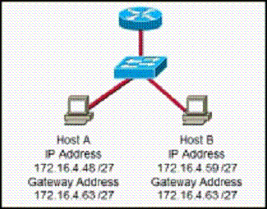

Refer to the exhibit. On the basis of the IP configuration that is shown, what is the reason that Host A and Host B are unable to communicate outside the local network?

|  |  |  |  |
| --- | --- | --- | --- |
| A. | Host A was assigned a network address. | C. | Host A and Host B belong to different networks. |
| B. | Host B was assigned a multicast address. | D. | The gateway address was assigned a broadcast address. |

____ 27. Using default settings, what is the next step in the router boot sequence after the IOS loads from flash?

|  |  |  |  |
| --- | --- | --- | --- |
| A. | Load the running-config file from RAM. | C. | Search for a backup IOS in ROM. |
| B. | Locate and load the startup-config file from NVRAM. | D. | Load the bootstrap program from ROM. |

____ 28. 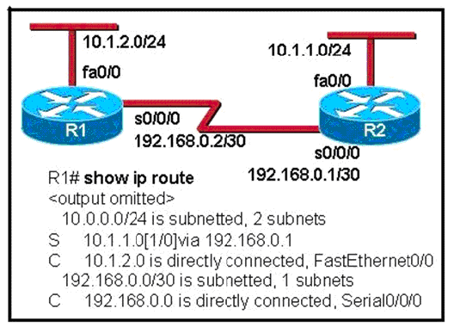

Which statement is true concerning the routing configuration?

|  |  |  |  |
| --- | --- | --- | --- |
| A. | Using dynamic routing instead of static routing would have required fewer configuration steps | C. | The 10.1.1.0/24 and 10.1.2.0/24 routes have adjacent boundaries and should be summarized |
| B. | Packets routed to the R2 Fast Ethernet interface require two routing table lookups | D. | The static route will not work correctly |

____ 29. When presented with multiple valid routes to a destination, what criteria does a router use to determine which routes to add to the routing table?

|  |  |  |  |
| --- | --- | --- | --- |
| A. | The router selects the routes with the lowest administrative distance. All routes with the same lowest administrative distance are added to the routing table. | C. | The router installs all routes in the routing table but uses the route with the best metric most when load balancing. |
| B. | The router selects the routes with the best metric. All routes that have the same best metric are added to the routing table. | D. | The router first selects routes with the lowest administrative distance. The resulting routes are then prioritized by metric and the routes with the best metric are added to the routing table. |

____ 30. 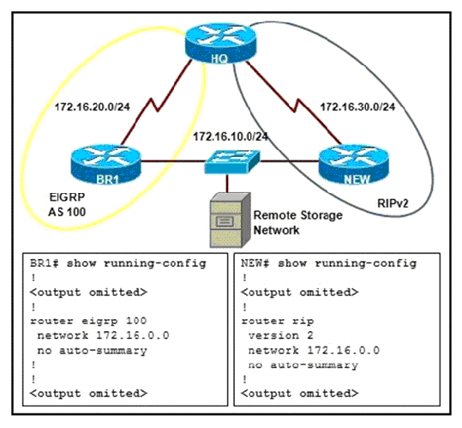

Refer to the exhibit. Two remote sites are connected to the HQ router. The router New is configured using RIPv2 and the router BR1 is configured using EIGRP. If HQ is configured with RIPv2 and EIGRP, how will the 172.16.10.0/24 network be added to the routing table of HQ after the network converges?

|  |  |  |  |
| --- | --- | --- | --- |
| A. | with one path to the 172.16.10.0/24 network via router BR1 | C. | with two paths of different cost to the 172.16.10.0/24 network |
| B. | with two paths of the same cost to the 172.16.10.0/24 network | D. | with one path to the 172.16.10.0/24 network via router NEW |

____ 31. 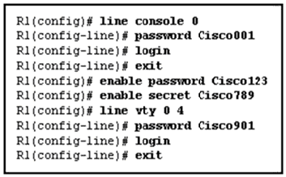

Refer to the exhibit. A network administrator is accessing router R1 from the console port. Once the administrator is connected to the router, which password should the administrator enter at the R1> prompt to access the privileged EXEC mode?

|  |  |  |  |
| --- | --- | --- | --- |
| A. | Cisco001 | C. | Cisco789 |
| B. | Cisco123 | D. | Cisco901 |

____ 32. A new network administrator is given the task of selecting an appropriate dynamic routing protocol for a software development company. The company has over 100 routers, uses CIDR and VLSM, requires fast convergence, and uses both Cisco and non-Cisco equipment. Which routing protocol is appropriate for this company?

|  |  |  |  |
| --- | --- | --- | --- |
| A. | RIP version 2 | C. | BGP |
| B. | EIGRP | D. | OSPF |

____ 33. 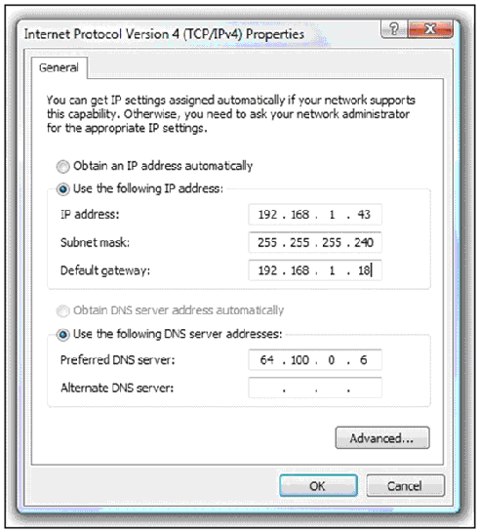

Refer to the exhibit. A PC is unable to communicate outside of the local network. A network technician views the host configuration and determines that the correct subnet mask but incorrect gateway was entered. What gateway IP address should be configured on the PC if the company policy requires that the IP address on a router interface is the highest in the subnet?

|  |  |  |  |
| --- | --- | --- | --- |
| A. | 192.168.1.62 | C. | 192.168.1.46 |
| B. | 192.168.1.126 | D. | 192.168.1.54 |

____ 34. 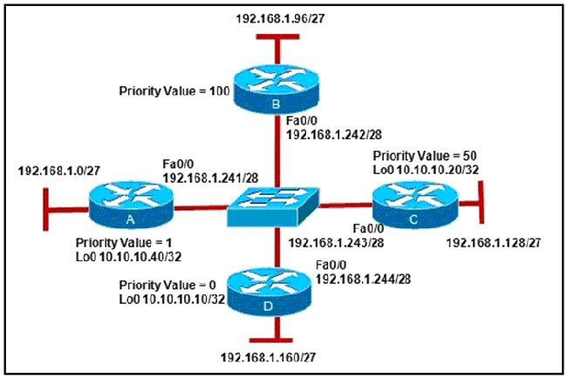

Refer to the exhibit. All the routers boot at the same time and enter the OSPF election process. Which router will be elected as the **BDR**?

|  |  |  |  |
| --- | --- | --- | --- |
| A. | router A | C. | router C |
| B. | router B | D. | router D |

____ 35. A router has a summary route to network 192.168.32.0/20 installed in its routing table. What range of networks are summarized by this route?

|  |  |  |  |
| --- | --- | --- | --- |
| A. | 192.168.32.0 – 192.168.47.0/24 | C. | 192.168.0.0 – 192.168.32.0/24 |
| B. | 192.168.32.0 – 192.168.63.0/24 | D. | 192.168.0.0 – 192.168.47.0/24 |

____ 36. What would be the appropriate VLSM for a network with 250 hosts that will not waste too many addresses?

|  |  |  |  |
| --- | --- | --- | --- |
| A. | 172.16.18.0/24 | C. | 172.16.16.64./30 |
| B. | 172.16.128.0/19 | D. | 172.16.64.0/18 |

____ 37. The following subnet masks have been chosen for use with the 192.168.16.0 network.

 255.255.255.252     255.255.255.240     255.255.255.192

Which of the following identify the most efficient use for each of these masks? (Choose 3)

A.  Use the /30 mask for point-to-point links, such as WAN connections

B.  Use the /25 mask for subnetworks with up to 30 hosts

C.  Use the /28 mask for small subnetworks with up to 14 hosts

D.  Use the /26 mask for larger subnetworks with up to 62 hosts

E.  Use the /24 mask for point-to-point links, such as WAN connections

|  |  |  |  |
| --- | --- | --- | --- |
| A. | A, B, C | C. | B, C, E |
| B. | A, D, E | D. | A, C, D |

____ 38. Which of the following are contained in the routing updates of classless routing protocols? (Choose two)

A. 32-bit address

B. next hop router interface

C. subnet mask

D. unicast host address

E. layer 2 address

|  |  |  |  |
| --- | --- | --- | --- |
| A. | A, C | C. | C, B |
| B. | A, B | D. | D, E |

____ 39. How does route poisoning prevent routing loops?

|  |  |  |  |
| --- | --- | --- | --- |
| A. | New routing updates are ignored until the network has converged. | C. | A route is marked as unavailable when its Time to Live is exceeded. |
| B. | The unreachable route is cleared from the routing table after the invalid timer expires. | D. | Failed routes are advertised with a metric of infinity. |

____ 40. What are two tasks that must be completed before two routers can use OSPF to form a neighbor adjacency? (Choose two)

|  |
| --- |
| A. The routers must elect a designated router. |
| B. The routers must agree on the network type. |
| C. The routers must use the same dead interval. |
| D. The routers must exchange link state requests. |
| E. The routers must exchange database description packets. |

|  |  |  |  |
| --- | --- | --- | --- |
| A. | A and B | C. | C and D |
| B. | B and C | D. | B and D |

____ 41. What does NAT do?

|  |  |  |  |
| --- | --- | --- | --- |
| A. | It allocates IP addresses for hosts to use on the local network. | C. | It translates between addresses at different OSI layers. |
| B. | It translates private IP addresses used inside a network into public addresses for use on the Internet. | D. | It translates public IP addresses used inside a network into private addresses for use on the Internet. |

____ 42. Which of the following application layer protocols use TCP?

1. TFTP 4. SNMP

2. FTP 5. DHCP

3. Telnet 6. VoIP

|  |  |  |  |
| --- | --- | --- | --- |
| A. | 2 and 3 | C. | 4 and 6 |
| B. | 1 and 5 | D. | 1 and 2 |

____ 43. 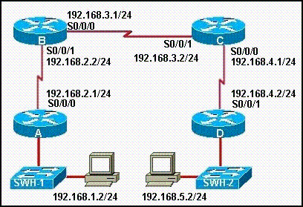

Refer to the exhibit. When the show cdp neighbors command is issued from router C, which devices will be displayed in the output?

|  |  |  |  |
| --- | --- | --- | --- |
| A. | B, D | C. | A, B |
| B. | A, B, D, SWH-1, SWH-2 | D. | D, SWH-2 |

____ 44. You have been asked to explain converged networks to a trainee. How would you accurately describe a converged network?

|  |  |  |  |
| --- | --- | --- | --- |
| A. | A network is converged when all routers have formed an adjacency. | C. | A network is converged when all routers flush the unreachable networks from their routing tables |
| B. | A network is converged after all routers share the same information, calculate best paths, and update their routing tables. | D. | A network is converged immediately after a topology change has occurred. |

____ 45. Which frames are flooded by a switch through all ports except the incoming port?

|  |  |  |  |
| --- | --- | --- | --- |
| A. | Unicast frames, multicast frames and frames where the source MAC address is not in the MAC address table. | C. | Broadcast frames, multicast frames and frames where the destination MAC address is not in the MAC address table. |
| B. | Broadcast frames, multicast frames and frames where there is no known switch port that matches the source MAC address. | D. | Broadcast frames, unicast frames and frames where there is no known switch port that matches the destination MAC address. |

____ 46. Another name for the MAC address table of a switch is the:

|  |  |  |  |
| --- | --- | --- | --- |
| A. | ARP table | C. | CAD table |
| B. | CAM table | D. | CDP table |

____ 47. Why is it advisable to put a switch IP address on some interface other than VLAN 1?

|  |  |  |  |
| --- | --- | --- | --- |
| A. | VLAN 1 cannot be associated with a physical interface in order for messages to be sent. | C. | VLAN 99 is the only interface that allows access to the web based interface. |
| B. | It is not possible to put an IP address on a VLAN interface. | D. | It is more secure to use a different VLAN interface for management purposes. |

____ 48. What device prepares data and also places it on the local loop for transmission to the service provider?

|  |  |  |  |
| --- | --- | --- | --- |
| A. | CSU | C. | DCE |
| B. | DTE | D. | CPE |

____ 49. What is the function of the Protocol field in a PPP frame?

|  |  |  |  |
| --- | --- | --- | --- |
| A. | It identifies the network layer protocol encapsulated in the frame’s Data field. | C. | It identifies the transport layer protocol that will process the frame. |
| B. | It identifies the application layer protocol that will process the frame. | D. | It identifies the data link layer protocol encapsulation in the frame’s Data field. |

____ 50. What is the default encapsulation for serial interfaces on a Cisco router?

|  |  |  |  |
| --- | --- | --- | --- |
| A. | PPP | C. | Frame Relay |
| B. | X.25 | D. | HDLC |