Contestant Number:
Time:
Rank:
FUNDAMENTALS OF
WEB DESIGN
(405)

REGIONAL – 2015

Multiple Choice & Short Answer Section:

Multiple Choice (20 @ 10 points each) (200 pts)

Application (205 pts)

TOTAL POINTS (405 pts)

Failure to adhere to any of the following rules will result in disqualification:
- Contestant must hand in this test booklet and all printouts. Failure to do so will result in disqualification.
- No equipment, supplies, or materials other than those specified for this event are allowed in the testing area. No previous BPA tests and/or sample tests or facsimile (handwritten, photocopied, or keyed) are allowed in the testing area.
- Electronic devices will be monitored according to ACT standards.

No more than ten (10) minutes orientation
No more than 90 minutes testing time
No more than ten (10) minutes wrap-up

Property of Business Professionals of America.
May be reproduced only for use in the Business Professionals of America
Workplace Skills Assessment Program competition.

Fill your answers in on the provided answer sheet.

- Which HTML tag creates a hyperlink?
- <link>
- <hyperlink>
- <a>
- <body>
- Which of these HEX RGB colors can be expressed using only three characters?
- #F6A244
- #FFF8DC
- #00CCGG
- #021FCD
- Which of the following is known as white space?
- The empty screen area around blocks of text and images
- The background color of white used for a page
- Both A and B
- None of the above
- Which HTML tag pair is used to specify table headings?
- <td> </td>
- <tr> </tr>
- <table> </table
- None of the above
- HTML stands for
- Hot Mail List
- Hypertext Markup Language
- Hypertext Scripting Language
- Hyper Markup Language

- The alt attribute of an <image> tag is
    - Required for HTML validation
    - Used by screen readers for visually impaired users
    - Displayed as a caption for an image with an alt attribute
    - All of the above
- Choose the correct way to horizontally center text within a <p> element.
    - CSS p {align:center}
    - CSS p {text-align: center}
    - HTML <p align=”center”>
    - HTML <center>
- Which one of the following organizations oversees the development of web technologies?
  - Internet Engineering Task Force (IETF)
  - New Consortium of Internet Services (NCIS)
  - World Internet Property Organization (WIPO)
  - World Wide Web Consortium (W3C)
- Which tag is used to force the browser to display the next text element on a new line?
  - <line/>
  - <br/>
  - <break/>
  - <nl/>
- Why should you include height and width attributes on <img/> tag?
  - They are required attributes and must always be included
  - They help the browser render the image faster because it reserves the appropriate space for the image
  - They help the browser display the image in its own window
  - None of the above
- What HTML element is used to place an image on a Web page?
  - <a href>
  - <img>
  - <image>
  - <graphic>
- Which of the following graphic types is best suited for photographs?
  - GIF
  - Photo
  - JPG
  - None of the above
- Which of the following is NOT a Web design recommended practice?
  - Design your site to be easy to navigate
  - Design colorful pages because they appeal to everyone
  - Design your pages to load quickly
  - Limit the use of animated items
- When text identifies a link, it often appears as __________ text.
  - Bolded
  - Indexed
  - Embedded
  - Underlined
- _____________ means to change heading styles, insert special characters and insert and / or modify other such elements that enhance the appearance of the Web page.
  - Coding
  - Formatting
  - Transitioning
  - Editing
- What is the correct HTML for inserting an image?
  - <img href=”image.gif” alt=”MyImage”>
  - <image src=”image.gif” alt=”MyImage”>
  - <img src=”image.gif” alt=”MyImage”>
  - <img alt=”MyImage”>image.gif </img>

- Which of the following can be a CSS selector?
  - A HTML element
  - A class name
  - An id name
  - All of the above
- An easy way to provide contact information is to include a(n) __________ link on a Website’s home page as well as other pages in the Website.
  - Connection
  - User
  - E-mail
  - Index
- A computer program that browses the World Wide Web in a methodical, automated manner and collects documents from the web to build a searchable index for the search engines
  - SEO
  - URL
  - Spider, Web Crawler or Bot
  - Web Browser
- Which type of HTML list is best used for glossary listings?
  - Definition list
  - Numbered list
  - Unordered list
  - Ordered list
Application
During this exercise, you are only allowed to use Notepad. The use of any other type of text editor such as Notepad++ or of web development tools such as Dreamweaver or Expression Web will result in immediate disqualification from this event.

A screen capture of the expected end result is included for your inspection and to be used as a guide for completing this exercise.

When complete, print all code generated for this exercise (HTML and Style Sheet). Also print a screen capture of your finished work as it appears in the web browser so that it may be used for grading purposes.

Submit all printed pages, along with your copy of this test, and your answer form to your proctor.

Your task is to regenerate the web page shown in the screen capture provided in this packet, using HTML5, CSS and the parameters specified below.

- Overall Specifications
  - The documents must be valid HTML5
  - The documents must be styled with an external cascading style sheet
    - ALL styling MUST be done with the style sheet. Using tags or style attributes within tags is PROHIBITED.
  - The document must not use tables for any sort of layout or positioning.

- General Page Specifications
  - Title should have Your Contestant Number – Fundamentals of Web Design
  - Background color #000080
  - Text color #000
  - The width of the page body needs to be 1000px
  - The default font for the page body needs to be Times New Roman, serif
  - The default font size needs to be 12pt
  - The page should have top and bottom margins of 0 and the left and right margins should automatically be centered in the browser window
  - Images must have the following style attributes
- Aligned to the Right or Left as shown in screen capture
- Padding 15px
  - The h1 headings must have the following style attributes:
    - “Arial” with fall back to sans-serif
    - Font size - 24pt
    - Font color - #000080
    - Font weight - normal
  - The h2 headings must have the following style attributes:
    - “Veranda” with fall back to sans-serif
    - Font size -14pt
    - Font color - #F00
    - Font weight - normal
  - The horizontal rule must have the following style attributes:
    - Height of 12px
    - Background color of #000080
  - Create a wrapper to hold all of the information on the page.
    - Width 1000px
    - Padding of 5px
    - Background color of #FFF

- Page Content
  - Amanda State Park – h1 & centered
  - Where Luxury and Rustic Come Together – h2 & centered
  - Insert a hard rule
  - Type the following paragraph
    - Located in Amanda, Ohio, Amanda State Park offers a little something for everyone. During the day enjoy hiking on our beautiful trails or swimming, boating and fishing in our crystal clear lake. Snowmobiling and sledding available in the winter months. In the evening enjoy music and dancing in our main lodge. Special entertainment for children is available in the main lodge Children's Center
  - Insert the image cabin.jpg
    - Format the image to width = 210, height = 134
    - Align the image to the left of the text
    - Code the image to have alternate text of “Cabin”
  - Insert the image jetski.jpg
    - Format the image to width = 181, height = 134
    - Align the image to the right of the text
    - Code the image to have alternate text of “Jet Ski”
  - Luxury Accommodations: - h2
  - Type the following in a bulleted list:
    - One, two and three bedroom cabins available
    - Full kitchens
    - Gas fireplaces, AC
    - TV, DVD player and free wireless Internet service
    - Whirlpool tubs and private decks with outdoor hot tub
    - Continental breakfast delivered to your front door (upon request)
      - (upon request) must be formatted with green text - #090
  - Rustic Accommodations: - h2
  - Type the following numbered list
    - Tent and RV sites available
    - Electricity available at select sites
    - Bath house with hot running water
  - Link the follow words “Please contact us for more information” to the e-mail address “information@amandapark.com.”

When finished creating the website, print the code and the screen capture of the browser page.
Turn in all printouts and your testing instructions to your proctor.

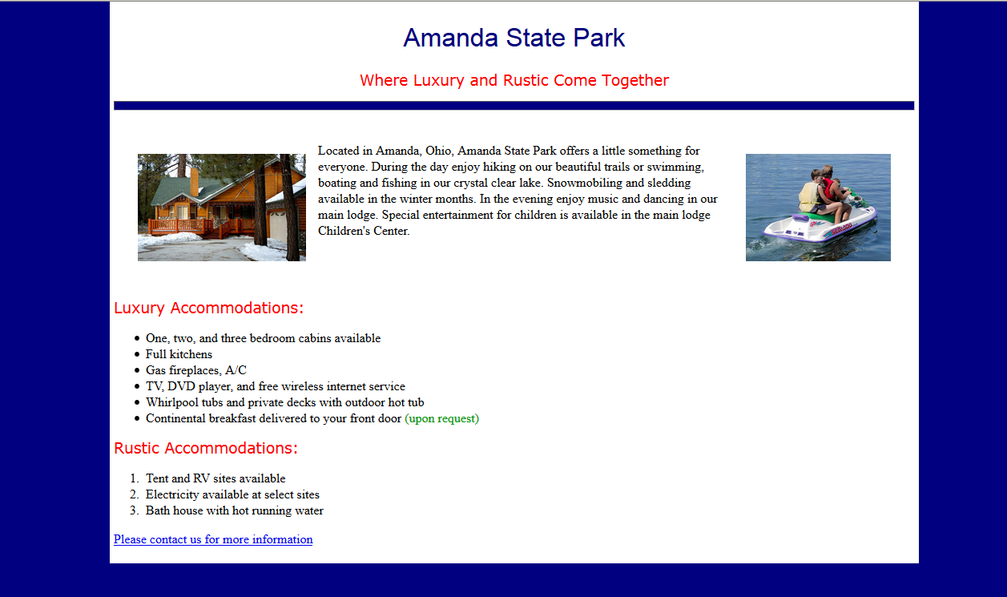
Sample Screen Capture

