Contestant Number:
Time:
Rank:

ADVANCED SPREADSHEET APPLICATIONS (235)

REGIONAL – 2015

TOTAL POINTS (380 points)

Failure to adhere to any of the following rules will result in disqualification:
- Contestant must hand in this test booklet and all printouts. Failure to do so will result in disqualification.
- No equipment, supplies, or materials other than those specified for this event are allowed in the testing area. No previous BPA tests and/or sample tests or facsimile (handwritten, photocopied, or keyed) are allowed in the testing area.
- Electronic devices will be monitored according to ACT standards.

No more than ten (10) minutes orientation
No more than 90 minutes testing time
No more than ten (10) minutes wrap-up

Property of Business Professionals of America.
May be reproduced only for use in the Business Professionals of America
Workplace Skills Assessment Program competition.

General Instructions

- Put your contestant number and printout number in the right section of the footer on each printout. Your name or initials should NOT appear on any work you submit.

- If you finish before the end of the testing time, notify the proctor. Time may be a factor in determining the winner in the event of a tie.

- When turning in your contest, the jobs should be arranged in printout order.

Formatting on consolidated, Indianapolis, Orlando, and Washington D.C. tabs | Points | Total
Contestant Number in the right section of footer | 5
Printout number in the right section of footer | 5
Sheet tab name in center section of footer | 5
Page of the number of pages in the center section of the header | 5
Title formatted with Title Cell style | 5
Title merged and centered across all columns | 5
Subtitle formatted with Title Cell Style | 5
Subtitle merged and centered across all columns | 5
Column headings with Heading 3 cell style | 5
Column headings background black text lighter 50% and white text | 5
Column B is formatted comma style, zero decimals | 5
Column C is formatted percent style, zero decimals | 5
Columns D through I formatted comma style | 5
Wrapped text on column headings where shown | 5
Renamed sheet tabs to match Title (header centered) | 5
Applied Total Cell style to Row 11 | 5
Subtotal | 80
Formulas on Indianapolis, Orlando, and Washington D.C. Tabs | Points | Total
Columns B, E through I are summed | 20
Formula in C5 compares if units on hand are greater than 50,15% , 0 | 20
Formula in E5 to figure Cost with Discount | 20
Formula in F5 takes units on hand times Cost with Discount | 20
Formula in G5 that adds a markup of 20% to Average Cost | 20
Formula in H5 that multiplies Units on hand times Average Selling Price | 20
Formula in I5 that takes total value minus total cost | 20
Subtotal | 140
Formulas on Consolidated Worksheet | Points | Total
Formula in B5 autosums other worksheet tabs B5 | 20
Formula in E5 averages the other worksheet tabs E5 | 20
Subtotal | 40
Chart | Points | Total
Chart is a 3-D pie chart with categories and Profit Potential | 10
Chart has legend removed | 10
Moved to own sheet tab without copy/paste | 10
Chart has title using WordArt saying Profit Potential | 10
Chart has textbox saying Highest Profit with black arrow pointing to largest percentage | 10
Chart has largest percentage piece of pie rotated so it is in the upper left corner | 10
Chart has highest percentage piece of pie pulled out | 10
Chart has Contestant number (5) and printout number in right section of footer (5) | 10
Typos all sheet tabs (0 errors 40 points, 1 error 35 points, 2 errors 30 points, 3 or more 0 points) | 40
Subtotal | 120
Total Points | 380

As an intern for Egg Head, you are making a template. Please type the information below into a spreadsheet.
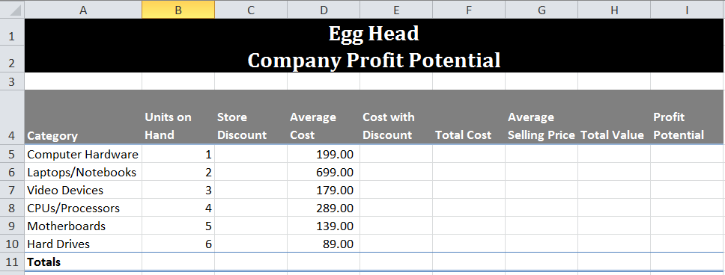

Please add the following formatting to the template:
- Merge and center across columns A1 through I1
- Merge and center across columns A2 through I2
- Apply title cell style to A1 through A2
- Apply black background to cells A1 through I2
- Apply white text to cells A1 through I2
- Word wrap where shown
- Apply Heading 3 cell style to Row 4
- Apply Black Text 1, lighter 50% to Row 4 background
- Apply white text to Row 4
- Apply comma style, no decimals to Column B
- Apply percent style, no decimals to Column C
- Apply comma style to D5 through I10
- Apply Total Cell style to Row 11
- Adjust Column width of Column A to 18, Columns B through I to 10.86

Please add the following formulas to the template:
- In Row 11, autosum columns B, and Columns E thorough I
- Insert in C5 a formula that will compare if units on hand are greater than 50 then put in 15% otherwise put in 0. Copy down.
- Insert in E5 a formula that will take average cost minus store discount times average cost. Copy down.
- Insert in F5 a formula that will take units on hand times Cost with discount. Copy down.
- Insert in G5 a formula that will add 20% of the average cost to the average cost. Copy down.
- Insert in H5 a formula that will multiply Units on hand times Average Selling Price. Copy down.
- Insert in I5 a formula that will take total value minus total cost. Copy down.

Make sure that you have four worksheet tabs.

Copy the contents of the worksheet to sheet tabs 2, 3 and 4. Rename the worksheet tabs so the original is named Consolidated, the second Indianapolis, the third, Orlando, the fourth Washington D.C.

Click on the Indianapolis worksheet. Change A1 through A2 background to be Dark Blue. Change subtitle to Indianapolis Profit Potential. Add the following units on hand to the worksheet:

Category | Units on hand
Computer Hardware | 40
Laptops/Notebooks | 15
Video Devices | 45
CPUs/Processors | 112
Motherboards | 101
Hard Drives | 200

Click on Orlando sheet tab. Change A1 through A2 background to be Red. Change subtitle to Orlando Profit Potential. Add the following information:

Category | Units on hand
Computer Hardware | 50
Laptops/Notebooks | 12
Video Devices | 105
CPUs/Processors | 114
Motherboards | 23
Hard Drives | 156

On the Washington D.C. tab. Change A1 through A2 background to be Purple. Change subtitle to Washington D.C. Profit Potential. Add the following information:

Category | Units on hand
Computer Hardware | 109
Laptops/Notebooks | 20
Video Devices | 76
CPUs/Processors | 89
Motherboards | 17
Hard Drives | 119

Click on the Consolidated tab. Make the following changes:
- In B5 insert a formula that will add the other sheets tabs B5 and copy down.
- In E5, insert a formula that will average the other sheet tabs E5 and copy down.

Chart

Using the Consolidated Worksheet, create a 3-D pie chart with Categories and Potential Profit. Move it to its own sheet tab. Remove the legend and add data labels of category name and percentage. Rotate the chart until the largest piece is in the upper left corner. Create a text box that says Highest Profit with a black arrow pointing to the one with the highest percentage. Pull the piece of pie out to emphasize more. Add a WordArt title of Profit Potential.

Print

Everything should in landscape, with the scaling to fit sheet on one page. Select all 4 sheets excluding the chart, and add a header centered with page number and the total number of pages and sheet tab name as a centered footer.
- Print out all 5 sheets including chart - making sure that no data is truncated
- Print consolidated worksheet showing formulas - making sure that no data is truncated.
- Print Indianapolis worksheet showing formulas - making sure that no data is truncated.

