Contestant Number:
Time:
Rank:

FUNDAMENTAL SPREADSHEET
APPLICATIONS
(230)

REGIONAL – 2015

TOTAL POINTS (310 points)

Failure to adhere to any of the following rules will result in disqualification:
- Contestant must hand in this test booklet and all printouts. Failure to do so will result in disqualification.
- No equipment, supplies, or materials other than those specified for this event are allowed in the testing area. No previous BPA tests and/or sample tests or facsimile (handwritten, photocopied, or keyed) are allowed in the testing area.
- Electronic devices will be monitored according to ACT standards.

No more than ten (10) minutes orientation
No more than 90 minutes testing time
No more than ten (10) minutes wrap-up

Property of Business Professionals of America.
May be reproduced only for use in the Business Professionals of America
Workplace Skills Assessment Program competition.

General Instructions

- Put your contestant number and printout number in the right section of the footer on each printout. Your name or initials should NOT appear on any work you submit.
- If you finish before the end of the testing time, notify the proctor. Time may be a factor in determining the winner in the event of a tie.
- When turning in your contest, the jobs should be arranged in printout order.

Printout 1 | Points | Total
Contestant Number in right sections of footer | 5
Printout number in right section of footer | 5
Title is merged and centered with Title cell style | 5
Subtitle Arial Black size 14 | 5
Column Headings have heading 3 style applied | 5
Row 14 has total style applied | 5
Row 14 height is adjusted appropriately | 5
Orientation is landscape | 5
Numbers are formatted comma style with no decimals | 5
Column width is adjusted appropriately (No truncation ) | 5
Typos (0 errors 40 points, 1 error 35 points, 2 errors 30 points, 3 or more errors 0 points) | 40
Total Printout 1 | 90 points
Printout 2 | Points | Total
Columns were named correctly LOOK IN B18 FORMULA, =COUNTA(Artist) If artist is not in the parenthesis, they do not get any credit. | 20
Total Column has correct formula - =SUM(B4:H4) | 20
Total Row has correct Formulas - =SUM(B4:B14) | 20
Average row has correct formulas - =AVERAGE(B4:B14) | 20
Highest row has correct formulas - =MAX(B4:B14) | 20
Lowest row has correct formulas - =MIN(B4:B14) | 20
Count row has correct formula - =COUNTA(Artist) or  =COUNT(A4:A14) | 20
Printed formulas on one sheet | 20
Total Printout 2 | 160 points
Printout 3 | Points | Total
Contestant Number in lower right | 10
Print number in correct spot (3) | 10
Chart title is correct | 10
No legend is shown | 10
Chart is on its own sheet tab | 10
Chart was made with correct data | 10
Total Printout 3 | 60 points
Total Points | 310 Points
Job 1

As an intern for the new record label, Pacific Records, you have been assigned to create a spreadsheet that will compare the number of new artists downloads for each month. The title of the spreadsheet is Pacific Records. The subtitle is New Artist Downloads. The download information is below:

Artist | July | August | September | October | November | December | January | Total
Athony Greer | 525,000 | 459,000 | 113,000 | 206,000 | 242,000 | 388,000 | 112,000
Summer Jones | 469,000 | 364,000 | 133,000 | 489,000 | 228,000 | 532,000 | 458,000
Leah America | 365,000 | 297,000 | 234,000 | 235,000 | 117,000 | 332,000 | 9,800
Jesse Downhill | 230,000 | 149,000 | 144,000 | 237,000 | 195,000 | 487,000 | 231,000
Michael Lopez | 225,000 | 24,000 | 28,000 | 178,000 | 361,000 | 381,000 | 303,000
Alex Tanner | 220,000 | 279,000 | 69,000 | 15,000 | 348,000 | 423,000 | 492,000
Josh Kilmer | 178,000 | 476,000 | 199,000 | 186,000 | 573,000 | 382,000 | 231,000
Ben Stop | 152,000 | 18,000 | 126,000 | 151,000 | 317,000 | 468,000 | 257,000
Josie Baaler | 135,000 | 476,000 | 135,000 | 28,000 | 168,000 | 287,000 | 521,000
Sean National | 117,000 | 398,000 | 63,000 | 184,000 | 334,000 | 297,000 | 524,000
Total
Average
Highest
Lowest
Number of Artists

- Please create named ranges using the Artist column heading label as names for the downloaded total numbers. So name the range A4:A13 to be named Artist.

- Insert a formula in the total column to add each Artist’s downloads.

- In the total row insert a formula to calculate each column’s total downloads (including the total column).

- In the Average row, insert a formula to calculate each column’s average downloads (including the total column).

- In the Highest row, insert a formula to calculate each column’s highest number of downloads (including the total column).

- In the Lowest row, insert a formula to calculate each column’s lowest number of downloads (including the total column).

- In the Number of Artist row, insert a formula that will count the number of artists. Do not copy, it should be in cell B17 only.

After creating the spreadsheet, make the following formatting changes:
- Merge and center Title and Subtitle across all used columns
- Apply Title cell style to the Title
- Change font of subtitle to Arial Black, size 14
- Change background of title and subtitle to Dark blue, text 2 background, white font
- Apply heading 3 cell style to Row 3
- Apply Total Cell style to Row 14
- Adjust column width of Column A to 16 and Columns B through I to 10
- Adjust row height of Row 14 to 30
- Apply comma style with no decimal places to all numbers.
- Change page orientation to landscape

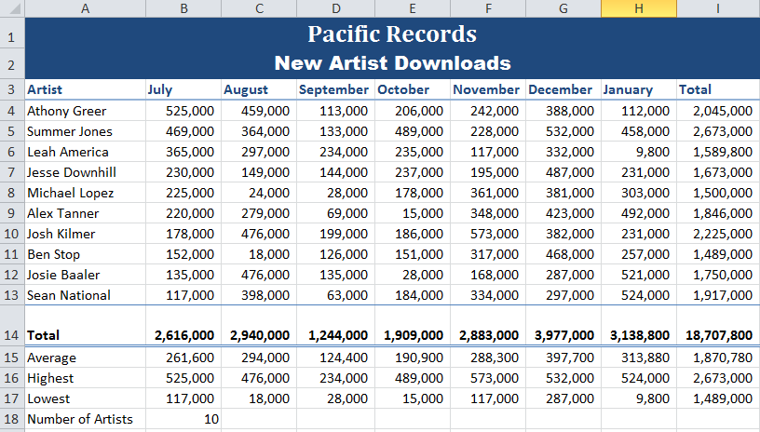
Printing:
- Print spreadsheet centered both horizontally and vertically making sure that no data is truncated. This is Printout 1.
- Show formulas, adjust scaling to fit on one page; widen columns as necessary to show all formulas. This is Printout 2.

Job 2

Please create a 3-D cluster column chart displaying each artists download totals. Do not show a legend and put it on its own sheet tab. The Chart Title is Total Downloads.

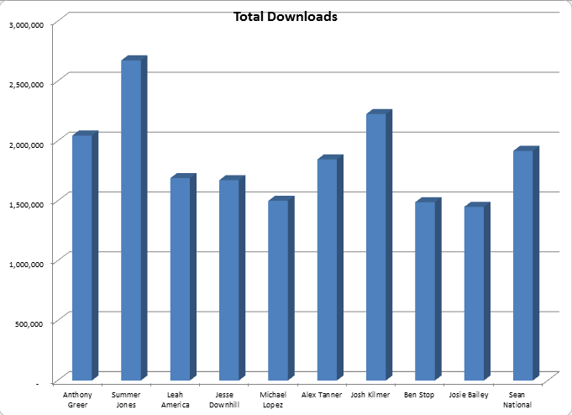
Printing:
- Printout 3—Print the chart.

