VISUAL BASIC PROGRAMMING (44)

Regional—2013

TOTAL POINTS ___________ (485)

Failure to adhere to any of the following rules will result in disqualification:
- Contestant must hand in this test booklet and all printouts. Failure to do so will result in disqualification.
- No equipment, supplies, or materials other than those specified for this event are allowed in the testing area. No previous BPA tests and/or sample tests or facsimile (handwritten, photocopied, or keyed) are allowed in the testing area.
- Electronic devices will be monitored according to ACT standards.

Complete and submit as directed by State Advisor

Property of Business Professionals of America.
May be reproduced only for use in the Business Professionals of America
Workplace Skills Assessment Program competition.

Note to Contestant:
The rubric for this event grants points for each minor task completed. That being the case, the contestant should strive to complete as many of the rubric items as possible. For grading purposes, this application must be written in VS10 or earlier. The contestant will need to refer to the form as it appears in the design mode in figures 1 – 7. Pay close attention to “What to Turn In” below.

The Application:
Enrico, BPA member since the 9th grade and currently enrolled in an Accounting program at Harris High School, wants a program to showcase his hobbies. His friend Sallee, a software development student at Harris, said she would assist in writing the program. They will call it “Hobby Hutch” and decided on the following:
- One form, frmMain, will contain all GUI
- Uncluttered opening view with a title and a menu strip, mnuMain, across the top, see figure 1
- A second menu strip on frmMain will render when the Photography tab is clicked, see figure 2
- Only the Photography segment of the program will be developed for now. The Photography routine will allow a student to select and individual picture to display or display all of the pictures. For now, only three pictures will be used. See technical specs

Technical Specs:
- Create a solution and project
  - Name the solution slnVbRegContestantNumber where contestant number is your contestant number (student ID)
  - Name the project: prjVbRegContestantNumber
  - Create two folders, one for Enrico’s images, one for menu icons. The folders must be a level one subfolder in the projects folder
  - Populate the folders with the files provided by the event administrator, see figure 8
- The form will contain the following controls and functionality:
  - In the code for the form, setup two regions: One for main menu processing, the other for Photo Menu processing
  - The “Hobby Hutch” heading as illustrated that remains centered left to right and anchored below the menu if the active form is stretched
  - Include in the main menu:
    - The 3 indicated menu tabs with the appropriate icons illustrated in figure 1. All menus and sub menus must have the icons illustrated in the figures below. The image names are indicative of the associated menu tab
    - The file menu tab will have one submenu, Exit, see figure 3
    - The Photography tab will redirect users to the Photography menu See figure 2
    - All tabs that do not redirect the user to an associated menu are considered under construction and will display a messageBox indicating such. NOTE: The under construction messageBox MUST be contained in a subroutine that WILL act as a shared event procedure for all menu tabs that are under construction.
    - The Music tab is under construction
  - Included in the Photography Menu illustrated in figure 2
    - Three indicated menu tabs
    - Populate the listBox (see figure 5), lstPics, with the names of the pictures in the images folder. Include <select a pic> as the first list item
    - Code the lstPics load event, do not use the collection parameter in the items property of the listBox
    - My Pictures tab will contain the sub menu tabs indicated in figure 4:
    - The Select Picture tab will initiate the following processing
      - Display lstPics
      - When a picture is selected from lstPics, the picture will display in a pictureBox as illustruated in figure 5
      - If a user clicks <select a pic>, display a messageBox directing the user to select a picture
    - The Display all Pictures tab will initiate the following processing:
      - All pictures will display in the pictureBoxes as illustrated in figure 6.
      - When a displayed picture is clicked, the picture will display in the larger pictureBox as illustrated in figure 7.
      - IMPORTANT: The contestant program must run from the student flash drive OR the graders computer, therefore, the code must fetch the image to display from the images folder using a relative, not an absolute path for both the Display All and Select Picture routine
    - The Photography Online tab is under construction
    - The To Main Menu tab redirects the user back to the main menu
    - All image container objects must be cleared when navigating between menus

In House Protocol
- Option strict must be set on
- Standard name prefixes must be utilized for form controls, coded variables, etc.
- All subroutines must be documented.
- Application documentation must be included
- Code duplication must be minimized
- The form must look like the examples given below
- Include a label in the lower right corner of the form with “Programmer: “ and your contestant number

What to turn in:
- Copy your solution/project with executable loaded onto the flash drive provided. Your project must be executable from the flash drive. If your solution/project cannot be opened and executed from the flash drive, your score will be zero. The project source code must be readable in the project in order to grade the code.

figure 1: The rendered top third of frmMain with menu 1 active

figure 2: The rendered top third of frmMain with menu 2 active

figure 3: The rendered top third of frmMain with mnuMain and only submenu.

figure 4: The rendered top third of frmMain with mnuPhototgraphy and MyPictures submenu
Figure 5 : The select picture routine in mnuPhototgraphy/MyPictures submenu
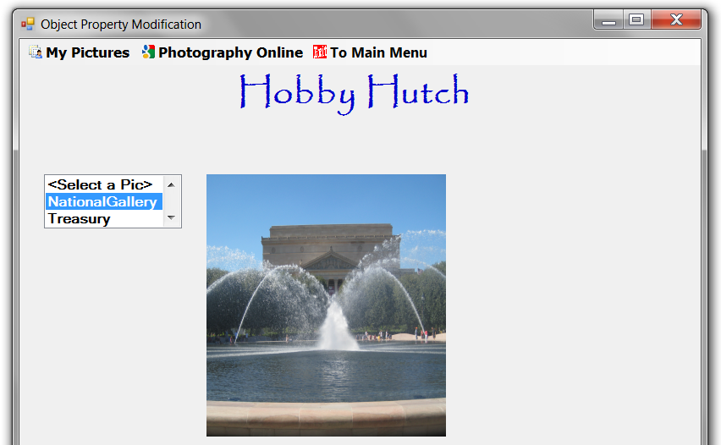

Figure 6: The All Pictures Displayed routine in mnuPhototgraphy/MyPictures submenu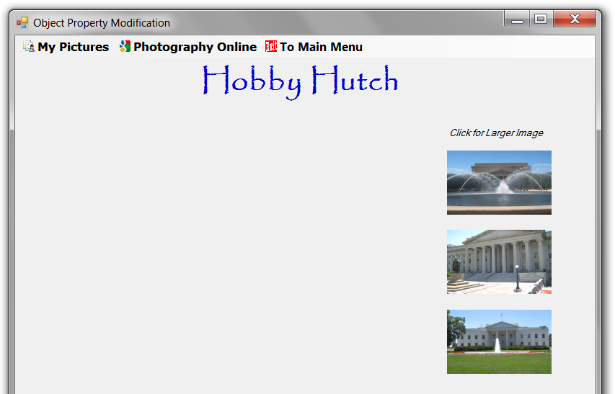

Figure7 : The All Pictures Displayed routine with picture selected when image is clicked
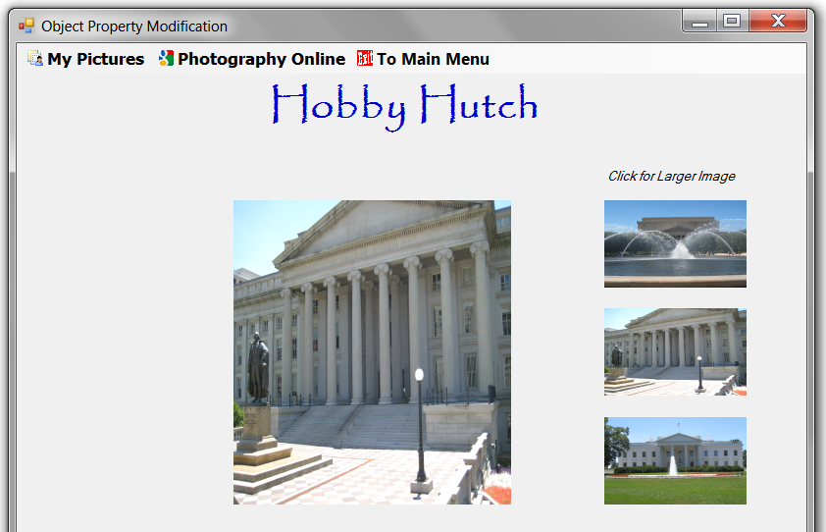

Figure8 : The projects explorer with images and menu icons expanded
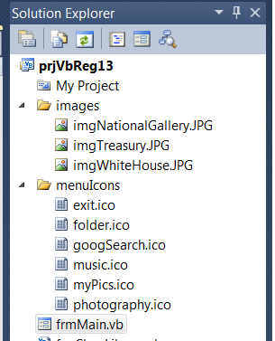

Grading Rubric  - Scoring the project  - Created solution/project as specified with contestant number (2@5pts)  - Created an icon and images folder (2@5pts) ……………………..……  - Populated the icon/images folders with the correct files (2@5pts) ….  - Scoring the form:  - Heading label is very similar to heading shown in fig 1……………….  - Form contains both menus either coded or tool bar object (2@10pts) ..  - ListBox, lstPics, present to select pictures ………….………..………..  - One large pictureBox to display the selected picture …………………  - 3 pictureBoxes for the “display all pictures” routine (3@5pts).................  - Label to display text “Click for larger image”……………………………  - Label with the <contestant number> in lower the right corner ……..…  - Scoring the code:  - Option Strict is set on ……………………………………………………..  - Two regions were created as indicated in the specs (2@5pts) …….....  - Code was written to load lstImages. The items prop was not used  - Code was written to fetch images utilizing a relative path as indicated  - The Under construction messageBox is contained in a subroutine that acts as a shared event procedure as indicated in the specs …….  - Each sub routine is documented ………………….…………………….  - The project is documented (above option strict)…….……..………….  - Standard prefix naming conventions utilized on controls/variables …  - Scoring the Execution, Main Menu  - Main Menu displays on open as indicated in figure 1 ………..…..……  - Photography menu is NOT displayed on open ………………………..  - Main Menu has 3 menu pads each with the appropriate icon (3@5pts)  - Heading is displayed ………………………………….……..……..……..  - Heading is properly docked/anchored when form is stretched ……….  - File menu pad has one submenu with icon …………………….............  - Exit menu pad exits the program ……………….…………………….….  - Photography menu pad redirects the user to the Photography menu..  - Music menu pad displays the “Under construction” message ………  - Scoring the Execution, Photography Menu  - Heading remains centered left/right and anchored top when rendered form is stretched……………………………………………………….…...  - Photography Menu displays on open see fig 1 …………………………..  - Main menu is NOT displayed on open …………………………...……..  - Photography Menu has 3 menu pads with appropriate icons (3@5pts)  - My Photography menu pad displays the submenus see fig 4 ………….  - IstPics displays correct data when Select Picture pad is clicked …….  - Correct picture displays when selected in lstPics see fig 5 …………….  - All pictures display when Display all Pictures menu pad is clicked fig 6  - Correct Small image, when clicked, displays in large picBox see fig 7....  - Photography Online pad displays Under Construction when clicked..  - To Main Menu pad returns user to the Main Menu …………………….  - When navigating between select Pic and Display All Pics, lstPics does not duplicate list items (remains at 3 items plus <select..> AND picBoxes clear and are appropriately visible (2@10pts)  TOTAL APPLICATION POINTS | _____(10)  _____(10)  _____(10) ______(30)  _____(05)  _____(20)  _____(10)  _____(05)  _____(15)  _____(05)  _____(10) ______(70)  _____(05)  _____(10)  _____(20)  _____(30)  _____(25)  _____(15)  _____(05)  _____(10) ______(120)  _____(05)  _____(10)  _____(15)  _____(05)  _____(10)  _____(05)  ____ (15)  ____ (10)  ____ (05) ______(80)  _____(10)  _____(05)  _____(10)  _____(15)  _____(10)  _____(15)  _____(25)  _____(30)  _____(20)  _____(10)  _____(15)  _____(20) ______(185)  ______(485)

