12 pages

ADMINISTRATIVE SUPPORT TEAM (30)

KEY

Regional– 2008

Production
Job 1 Memorandum _____ (150 pts.)
Job 2 Spreadsheet _____ (250 pts.)
Job 3 Database _____ (150 pts.)
Job 4 Presentation _____ (320 pts.)

TOTAL _____ (870)

Judges/Graders:

Please double-check and verify all scores!

Property of Business Professionals of America.
May be reproduced only for use in the Business Professionals of America
Workplace Skills Assessment Program competition.
ADMINISTRATIVE SUPPORT TEAM
REGIONAL 2008
KEY
Page 2 of 14

GENERAL INSTRUCTIONS

- Check that this test booklet contains Jobs 1-4.
- Correct all errors. Copy is graded on production standards along with additional criteria.
- In places you normally use your reference initials, use your contestant/team number.
Your name or initials should NOT appear on any work your team submits. Key your contestant/team number and job number in the footer in the lower left corner of all work submitted unless specified otherwise.
- If you finish before the end of the testing time, notify the proctor. Time may be a factor in determining the winner in the event of a tie.
- When turning in your contest, the jobs should be arranged in numeric order. Use your time wisely. You have 90 minutes to complete this test.

Production Standards:
0 errors = 100 points
1 error = 90 points
2 errors = 70 points
3+ errors = 0 points

TEAM INSTRUCTIONS

You are part of the administrative support team for the Human Resource Department at Professional Business Associates, 5454 Cleveland Avenue, Columbus, OH 43231-4021. Julie Smith, your supervisor, is the director of Human Resources for the company. You have been charged with the task of setting up the new employee orientation scheduled for March 10-11.

Ms.Smith will be out of town and has asked you and your team to perform the following functions:

Job 1 – Memorandum – one inch margins
MEMORANDUM

TO: Mike DeLaney, Director of Property Management

FROM: Julie Smith, Director of Human Services

DATE: February 18, 2008

SUBJECT: Room Reservation—Auditorium

I would like to request the auditorium for March 10-11 for new employee orientation. The room should be available for our exclusive use from 8:00 a.m. to 4:30 p.m.

The following items need to be ready for use:

- Computer with internet connection
- DVD player
- Video projector (for computer and DVD use)
- One table in the lobby with two chairs
- Two tables in the back of the auditorium
Please note that the last time we used the auditorium, the shades on the clerestory windows would not close with the remote control which made it difficult to see the screen. Can you see that maintenance has checked that the blinds actually close with the remote?

Finally, I need to leave some boxes in the auditorium overnight and would like to secure the room. Do you arrange this with security or should I contact them? Thanks for your attention in these matters.

I’ve also attached the proper room request form.

Contestant number

Attachment

Scoring
Job 1 – Memorandum
Production standards
(including Job 1 and Team # in footer but excluding embedded errors)
100 points ______
Embedded errors corrected (five points each) 50 points ______
Total 150 points ______
Scoring
Job 2 – Spreadsheet
Award points as follows:
Printed spreadsheet 100 points ______
Deduct 20 points each for missing title(s)/date
Deduct 10 points each for incorrect title formatting
Deduct 10 points if ‘Job 2-Team #’ is not in footer
Deduct 10 points if not in landscape orientation
Deduct 10 points if not centered horizontally
Deduct 10 points if gridlines do not show
Deduct 10 points if printout exceeds one page
Printed formula spreadsheet 50 points ______
Deduct 10 points each for incorrect formulas
Deduct 10 points if printout exceeds one page
Deduct 10 points if ‘Job 2-Team #’ is not in header
Production standards (spelling errors on main spreadsheet printout) 100 points ______
Total Possible 250 points ______

Job 2 – Spreadsheet Printout (* May have 0.00)

PROFESSIONAL BUSINESS ASSOCIATES
New Employee Orientation Checklist
March 10-11, 2008
Count | Measure | Item | Source | Cost per Measure | Total Cost | Date Needed | Date Completed
2 | Each | Coffee pots | Human Resources | - * | - *
2 | Pounds | Regular coffee | Cafeteria | 8.25 | 16.50
2 | Pounds | Decaffeinated coffee | Cafeteria | 8.75 | 17.50
1 | Box | Assorted teas | Cafeteria | 7.75 | 7.75
3 | Dozen/day | Donuts | Donut-Rama | 6.75 | 20.25
12 | Each | Name tags (personalized) | Human Resources | 5.20 | 62.40
12 | Each | Welcome bags | Human Resources | 10.00 | 120.00
12 | Each | Insurance packets | Insurance Department | 2.00 | 24.00
12 | Each | Policy booklet | Human Resources | 12.25 | 147.00
12 | Each | Parking permits | Security | 5.75 | 69.00
2 | Each | Floral arrangement | Flower Nook | 26.50 | 53.00
Total |  |  |  |  | $ 537.40

Job 2 – Formula Printout (Formula may vary by cell placement or makeup, but must produce same result)

PROFESSIONAL BUSINESS ASSOCIATES
New Employee Orientation
March 10-11, 2008
Count | Measure | Item | Source | Cost per Measure | Total Cost | Date Needed | Date Completed
2 | Each | Coffee pots | Human Resources | 0 | =A5*E5
2 | Pounds | Regular coffee | Cafeteria | 8.25 | =A6*E6
2 | Pounds | Decaffeinated coffee | Cafeteria | 8.75 | =A7*E7
1 | Box | Assorted teas | Cafeteria | 7.75 | =A8*E8
3 | Dozen/day | Donuts | Donut-Rama | 6.75 | =A9*E9
12 | Each | Name tags (personalized) | Human Resources | 5.2 | =A10*E10
12 | Each | Welcome bags | Human Resources | 10 | =A11*E11
12 | Each | Insurance packets | Insurance Department | 2 | =A12*E12
12 | Each | Policy booklet | Human Resources | 12.25 | =A13*E13
12 | Each | Parking permits | Security | 5.75 | =A14*E14
2 | Each | Floral arrangement | Flower Nook | 26.5 | =A15*E15
Total |  |  |  |  | =SUM(F5:F15)

Scoring
Job 3 – Database
Award points as follows:
Printed database 100 points ______
Deduct 5 points for each misspell (data that cannot be seen is an error)
Deduct 20 points for missing records
Deduct 50 points if created in spreadsheet
Deduct 20 points if printout is not in landscape or exceeds one page
Deduct 10 points if ‘Job 3-Team #’ is not in top row and footer
Printed report 50 points ______
Deduct 20 points if extra fields are included
Deduct 10 points if required field is missing
Deduct 10 points if not in alpha order in each group
Deduct 10 points if data is truncated
Deduct 10 points if not labeled “Job 3-Team #” and if same is not listed in footer
Total Possible 150 points ______

Job 3 - Team #
First Name | Last Name | Address | City | State | Zip | Phone | Department | Position
David | Cromwell | 1186 Van Buren | Columbus | OH | 43201 | 614-238-9082 | Financial Services | Filing Clerk
Cassandra | Dent | 645 Thirty-Eighth St. | Columbus | OH | 43202 | 614-561-1343 | Marketing | Product Information
Jason | DeVries | 269 Crestmoor | Columbus | OH | 43223 | 614-240-1329 | Information Technology | Reception
Carrie | Durst | 926 Abby Lane | Columbus | OH | 43201 | 614-238-6969 | Human Resources | Reception
Mike | Fischer | 338 NE Cherry | Columbus | OH | 43223 | 614-238-6777 | Marketing | Filing Clerk
Lori | Harrison | 863 Oak Street | Columbus | OH | 43201 | 614-238-6983 | Administrative Support | Mail Room
Tim | Hart | 226 SE 10th | Columbus | OH | 43201 | 614-238-1440 | Financial Services | Accounts Payable
Michael | Johnson | 8284 Westmoreland | Westerville | OH | 43081 | 614-414-2131 | Information Technology | Webmaster
Nick | Keller | 628 Huntington | Columbus | OH | 43210 | 614-240-6382 | Financial Services | Accounts Receivable
Penny | Sampson | 1420 W. Fifth | Columbus | OH | 43210 | 614-238-8022 | Information Technology | Network Administration
Roslyn | Williams | 1257 Jefferson Lane | Columbus | OH | 43202 | 614-234-5897 | Information Technology | Database Management

Job 3 – Tabular Report Printout – Fonts may vary from example

Job 3 - Team #
Last Name First Name Department Position
Cromwell David Financial Services Filing Clerk
Dent Cassandra Marketing Product Information
DeVries Jason Information Technology Reception
Durst Carrie Human Resources Reception
Fischer Mike Marketing Filing Clerk
Harrison Lori Administrative Support Mail Room
Hart Tim Financial Services Accounts Payable
Johnson Michael Information Technology Webmaster
Keller Nick Financial Services Accounts Receivable
Sampson Penny Information Technology Network Administration
Williams Roslyn Information Technology Database Management
Scoring
JOB 4 – PRESENTATION KEY
Note to graders: There should only be six slides printed in ‘handout’ format as illustrated below. Text should be similar in order. There should be evidence of bulleted/numbered lists (not all the same), auto shapes, software-supplied clipart, background, and symbols. Deduct points if text is not easily readable.

Award points as follows:
Slide Presentation 100 points ______
Deduct 25 points for each missing slide
Deduct 25 for improper print out (should be handout style, six per page)
Award 10 points for graphics/clip art (software supplied) 50 points ______
Award 10 points for bullets/numbering on each slide 50 points ______
Award 10 points for ‘Prepared by Team #’ on title slide 10 points ______
Award 10 points for ‘Prepared by Team #’ in footer of following slides 10 points ______
Deduct 10 points if footer appears on title slide
Production Standards (misspells, missing information) 100 points ______
Total Possible 320 points ______

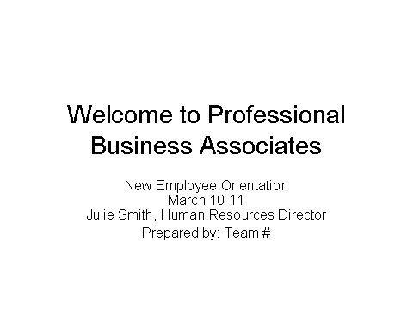 |  | 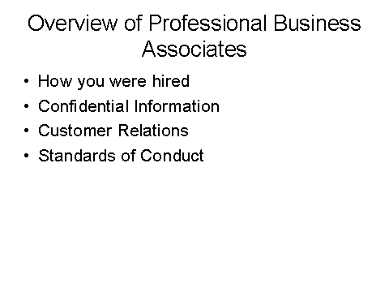
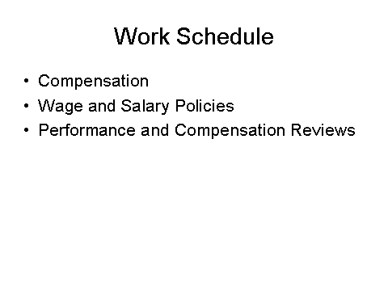 |  | 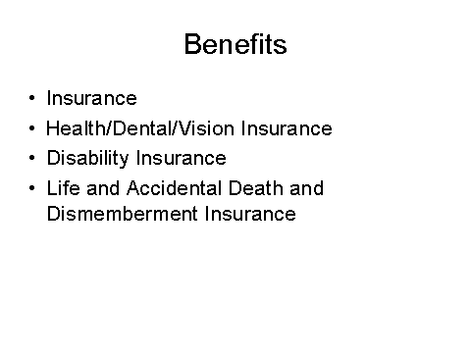
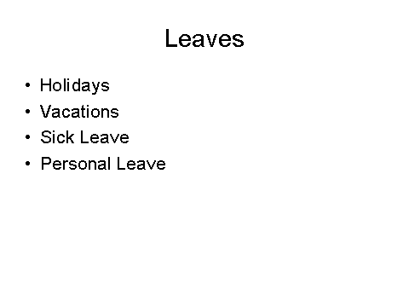 |  | 