DESKTOP PUBLISHING (24)

KEY

Regional– 2008

Production

Job 1 Poster _______ (150 pts.)

Job 2 Coupon _______ (150 pts.)

Job 3 Post Card _______ (150 pts.)

TOTAL POINTS _______ (450)

Judges/Graders:

Please double-check and verify all scores!

Property of Business Professionals of America.
May be reproduced only for use in the Business Professionals of America
Workplace Skills Assessment Program competition.

SCORE SHEET
Job 1- Poster Points Score Total
1. Completeness of information 20 _______
2. Correct size & orientation 10 _______
3. Includes graphic image(s) 10 _______
4. Accurate spelling, punctuation, & grammar 10 _______
5. Effective use of fonts, type styles, & type sizes 20 _______
6. Creativity 30 _______
7. Overall design & appearance 50 _______
Total 150 _______

Job 2- Coupon Points Score Total
1. Completeness of information 20 _______
2. Correct size & orientation 10 _______
3. Includes graphic image(s) 10 _______
4. Accurate spelling, punctuation, & grammar 10 _______
5. Effective use of fonts, type styles, & type sizes 20 _______
6. Creativity 30 _______
7. Overall design & appearance 50 _______
Total 150 _______

Job 3- Post Card Points Score Total
1. Completeness of information 20 _______
2. Correct size & orientation 10 _______
3. Includes graphic image(s) 10 _______
4. Accurate spelling, punctuation, & grammar 10 _______
5. Effective use of fonts, type styles, & type sizes 20 _______
6. Creativity 30 _______
7. Overall design & appearance 50 _______
Total 150 _______

TOTAL POINTS 450 _______

GENERAL INSTRUCTIONS

- Make certain the test booklet contains Jobs 1-3.
- Correct all errors. Copy will be graded on accuracy, creativity, originality, adherence to design principles such as: contrast, emphasis, visual hierarchy, flow and overall appearance.
- Key your contestant number and job number in the upper right-hand corner of all work submitted. Your name or initials should not appear on any work that you submit.
- Rough drafts should be limited and submitted behind your final product. Place an X across each rough draft page. You will not be judged on the rough drafts.
- Software templates may be used, but creativity points may be reduced.
- Only the graphics provided may be used. You may, however, use WordArt, lines, circles, squares, rectangles, polygons, and/or AutoShapes. In addition, you may modify the graphics supplied.
- If you finish before the end of the testing time, notify the proctor. Time may be a factor in the event of a tie.
- Be sure to print in black and white only. Printing in color will result in disqualification.
- When turning in your work, place your Scoring Sheet on the top of your jobs. Jobs should be arranged in numeric order.

Directions:

Use only the graphics supplied for the test. For your use, the graphics included are printed on the last page of this test. These graphics may be modified for use. WordArt, lines, circles, squares, rectangles, polygons, and/or AutoShapes may also be used. All designs will be graded on the effectiveness and application of the following design principles: contrast, emphasis, visual hierarchy, and flow.

Job 1: Poster

Professional Business Associates will conduct a fundraiser by sponsoring the Broadway production of The Lion King at Lafayette High School; 21346 Worldview Avenue, Lafayette, Ohio, September 14, 2008, at 7:00 p.m. Tickets are $35, which will include the cost of admission and a light snack at intermission.

Play Description that appears in Playbill:

The Lion King is a musical story of a young lion cub named Simba who struggles to accept the responsibilities of adulthood and his destined role as king. The Lion King has pulsating rhythms of the African Pride Lands and an unforgettable score including Elton John and Tim Rice’s Oscar-winning “Can You Feel the Love Tonight.” Treat yourself, your friends and family to a memory that will last a lifetime at the Lafayette High School Broadway production of The Lion King.

Tickets can be purchased at the school before the performance or the night of the performance (if not sold out).

- You are to create a poster on paper sized 8 ½” x 11” in portrait orientation using the following techniques:
- Use typography to effectively create a focal design
- Use white space as part of your design
- Include essential information about the play from the Playbill description
- Apply effective use of the proximity principle
- Bold text your contest number in the upper right-hand corner

Job 2: Coupon

- Professional Business Associates has joined forces with Subs n’ Subs, to assist in raising funds and is offering a $5 coupon off any order of $12 to each patron who attends the play. Coupons must be presented the week after the play
- Create a 3” x 6” coupon, landscape orientation.
- Create a rectangle sized 2 ½” x 5 ½” for your coupon.
- Use a dashed line 2.5 point weight around your rectangle.
- Key the following information in the box:
Professional Business Associates appreciates your participation in our fundraiser. To thank you, we are presenting you with a $5.00 off coupon redeemable at Subs n’ Subs during the week of September 14 through September 21. This coupon is only good on orders of $12 or more.
- Place the face value ($5) of the coupon in the center of your rectangle.
- Create a signature line aligned to the right with a weight of .5” and a length of 2”.

Job 3: Postcard Advertisement

- Create a 2-sided advertisement, 4.5” x 5.5”, for The Lion King at Lafayette High School September 14, 2008, at 7:00 p.m., admission cost $35, presented by Professional Business Associates.
- Your design should incorporate the following:
- Create a design for the front of the advertisement.
- The back side should have a placeholder for postage stamp.
c. Information about the play
- Date, time, place and cost
- The Subs n’ Subs coupon, (which will appear in the playbill)
- Your design should include at least one graphic.

DESKTOP PUBLISHING
GRAPHICS FOR REGIONAL TEST
 |  | 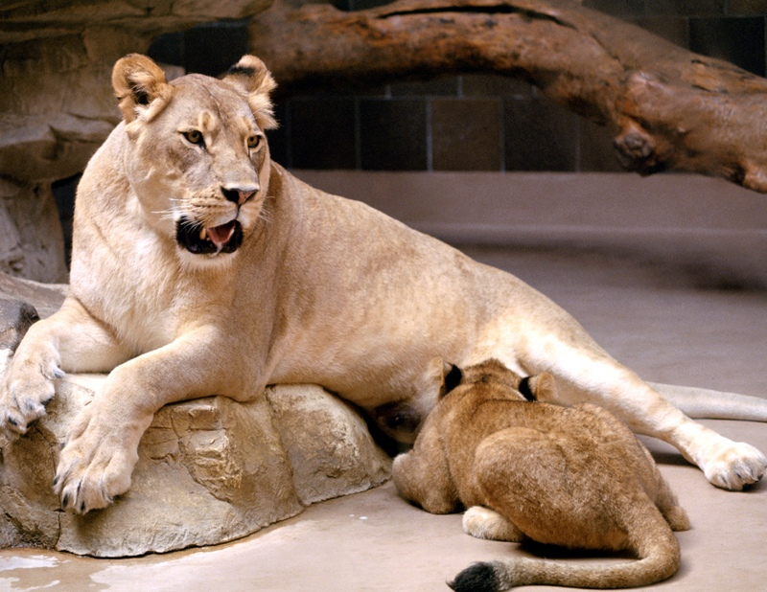 | 
Lion1 | Lion2 | Lion3 | Lion4
 |  |  | 
Tickets | People | Drums | Theater
 | 
Scissors | Coming Soon | Lion5

